**1.INTRODUCTION**

**1.1 PROBLEM DEFINITION**

During the pandemic time, Students faced a lot of problems in terms of their education. Most of the schools /colleges had online platform of learning. But in that, There was really less / No interaction. And students were not clearly understanding the concepts.As we move further with online based system, the learning has become quite easy, but it is not effective.

According to report by O. Simpson— “78% of students fail to finish their courses.The predominant reason of students dropping an online course is lack of student engagement”.The requisite activities and materials for the next assessment”.Since more than required notes are available to study.

**1.2 SCOPE OF THE APP**

The Objective of This “EDUCATOR” App Is to Provide an interface so that people can share their thoughts.

* Easy and highly interactive user interface.
* Enhanced Learning
* Create And Recommend Modules
* Create And Analize Learning Pattern
* Implement Recommendation Through Machine Learning Algorithm

**MODULES**

* **User Validation :** To Validate Users
* **Course Recommendation :**Recommend New Courses
* **Payment Gateway:** Payment of Course To Access It
* **Module / Syllabus Recommendation :** Decide Learning Roadmap.
* **Content Delivery :** Learning Place.
* **User’s Statistics:** Analyze User’s Performance
* **Wishlist:** Bookmark A Course For Later Use.

**2.SYSTEM STUDY**

**2.1 EXISTING SYSTEM**

In modern online learning app, all students are who enroll in a particular course are provided with same content. But learning capability of every student is not same. Therefore, grasping the knowledge may become too much of some student and too less to others. In other online app. The content provided was vague and general to all student. It was not specific to a particular student group.

**2.2 FEASIBILITY STUDY**

In other online app. The content provided was vague and general to all student. It was not specific to a particular student group. But our app “Educator” Gives a customized learning experience which Increases productivity in learning by providing a learning roadmap to it.

The pace of student’s learning is quite different, some might learn fast, some takes a lot of time.If the notes are quite easy, a fast learner might feel bored and lose interest. If we keep too complicated, slow learners might feel this is beyond us and never try to learn.So by making average type of learning is one solution, but we will not get an optimized way of doing it. So by customizing our learning pattern, we can achieve our objective.

**2.3 PROPOSED SYSTEM**

This is an online learning platform in which students can learn any course at their own pace. It is different from other online learning platform. That it not only customize and recommend courses, but also it customizes modules / syllabus to each and every student with the help of Deep/Machine learning algorithms.So, in order to provide required learning, This app “Educator” Cluster students based on their performance and provide required modules in order to fulfill the course. This creates less burden on students in learning period and fully understand the taught concepts.

**ADVANTAGES OF PROPOSED SYSTEM**

* Easy To Use
* Highly Interactive UI
* Real Time Learning
* Customized Learning To Each Particular Group
* More Learning Capabilities

**OBJECTIVES OF PROPOSED SYSTEM**

The study of existing system is the exact nature of problem manual system. Also, if has been decided that problem in the existing system can be solved only through computerization.

**MACHINE LEARNING MODELS USED**

**Liner Discriminat Analizer:**

Linear discriminant analysis is an extremely popular dimensionality reduction technique. Dimensionality reduction techniques have become critical in machine learning since many high-dimensional datasets exist these days. Linear Discriminant Analysis was developed as early as 1936 by Ronald A. Fisher. The original Linear discriminant applied to only a 2-class problem. It was only in 1948 that C.R. Rao generalized it to apply to multi-class problems. It is used as a dimensionality reduction technique. Also known as a commonly used in the pre-processing step in machine learning and pattern classification projects.

**Cosine Based Recommendation System**

These algorithms recommend items similar to the ones a user liked in the past. We’ll review different similarity functions and you’ll then be able to choose the more suitable one for your system. The main input is the Item-Content Matrix (ICM) which describes all the attributes for each item. We’ll see how we can improve the quality of content-based techniques, by normalising and tuning the importance of each attribute in the ICM: you’ll be able to use some specific tuning strategies in order to obtain the best quality recommendations from your system. So, at the end of this module, you’ll know how to build a content-based recommender system, how to clean and normalize your input data.

**Dataset Used:**

The Data from a group of college students of ‘Kristu Jayanti College’ who're pursuing BCA [Bachelor’s in Computer Application]. They took a test on a particular subject, “Operating System Concepts & UNIX/LINUX”. This was a pre-course test to perceive the simple idea of the subject from the college students. The test was split into 10 questions. Each question has its very own weights based on its importance. The questions are divided into 3 levels easy, average, hard.

**3. System Design**

It Is Also One of The Most Crucial Step In Software Development.  In the design phase, the architecture is established. This phase starts with the requirement document delivered by the requirement phase und maps the requirements into an architecture.The design may include the usage of existing components Analysing the trade-offs of necessary complexity allows for many things to remain simple which, in turn, will eventually lead to a higher quality product. The architecture team also converts the typical scenarios into a test plan.System design is the process of defining the architecture components, modules interfaces and data for a system to satisfy specified requirements. Systems design could be seen as the application of systems theory to product development. There is some overlap with the disciplines of system analysis, systems architecture and systems engineering,

**Logical design**

The logical design of a system pertains to an abstract representation of the data flows, inputs and outputs of the system. This is often conducted viu modelling, using an over-abstract (and sometimes graphical) model of the actual system, In the context of systems, designs are included. Logical design includes entity-relationship diagrams (ER diagrams).

**Physical design**

The physical design relates to the actual input and output processes of the system. This is explained in terms of how data is input into a system, how it is verified/authenticated, how it is processed, and how it is displayed. In physical design, the following requirements about the system are decided.

• Input requirement

• Output requirements

• Storage requirements

• Processing requirements

• System control and backup or recovery:

Put another way, the physical portion of system design can generally be broken down i**nto three** sub-tasks:

**User Interface Design** is concerned with how users add information to the system and with how the system presents information hack to them.

**Data Design** is concerned with how the data is represented and stored within the system.

**Process Design** is concerned with how data moves: through the system, and with how and where it is validated, secured and/or transformed as it flows into through and out of the system.

**3.1 ER DIAGRAM**

An Entity Relationship Diagram (ERD) shows the Relationships of Entity sets stored in a Database. An Entity in this context is a component of data. In other words, ER diagrams illustrate the logical structure of databases.At first glance an entity relationship diagram looks very much like a flowchart. It is the specialized symbols, and the meanings of those symbols, that make it unique. Because this ER tutorial focuses on beginners below are some tips that will help you build effective ER diagrams:

* Identify all the relevant entities in a given system and determine the relationships among These entities.
* An entity should appear only once in a particular diagram.
* Provide a precise and appropriate name for each entity, attribute, and relationship in the diagram. Terms that are simple and familiar always beats vague, technical-sounding words.
* In naming entities, remember to use singular nouns. However, adjectives may be used to distinguish entities belonging to the same class. Meanwhile attribute names must be meaningful, unique, system independent, and easily understandable.
* Remove vague, redundant or unnecessary relationships between entities.
* Never connect a relationship to another relationship.
* Make effective use of colours. You can use colours to classify similar entities or to highlight key areas in your diagrams.

You can draw entity relationship diagrams manually, especially when you are just informally showing simple systems to your peers. However, for more complex systems and for external audiences, you need diagramming software such as flow.io to craft visually engaging and precise ER diagrams. The ER Diagram Software offered by flow.io as an online service is pretty easy to use and is a lot more affordable than purchasing licensed software.

It is also perfectly suited for development teams because of its strong support for collaboration. There are five main components of an ERD:

* **Entities,** which are represented by rectangles. An entity is an object or concept about which you want to store information
* 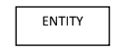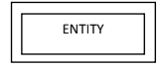**A weak entity** is an entity that must defined by a foreign key relationship with another entity as it cannot be uniquely identified by its own attributes alone.
* 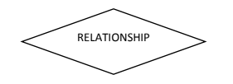**Relationship** , which are represented by diamond shapes, show how two entities share information in the database. In some cases, entities can be self-linked.
* **Attributes**, which are represented by ovals. A key attribute is the unique, distinguishing characteristic of the entity.
* A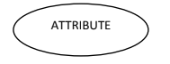 **multivalve attribute** can have more than one value. A derived attribute is based on another attribute.
* 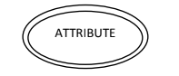 **Connecting lines**, solid lines that connect attributes to show the relationships of entities in the ER Diagram.

**Cardinality** specifies how many instances of an entity relate to one instance of another entity

**ER Diagram**

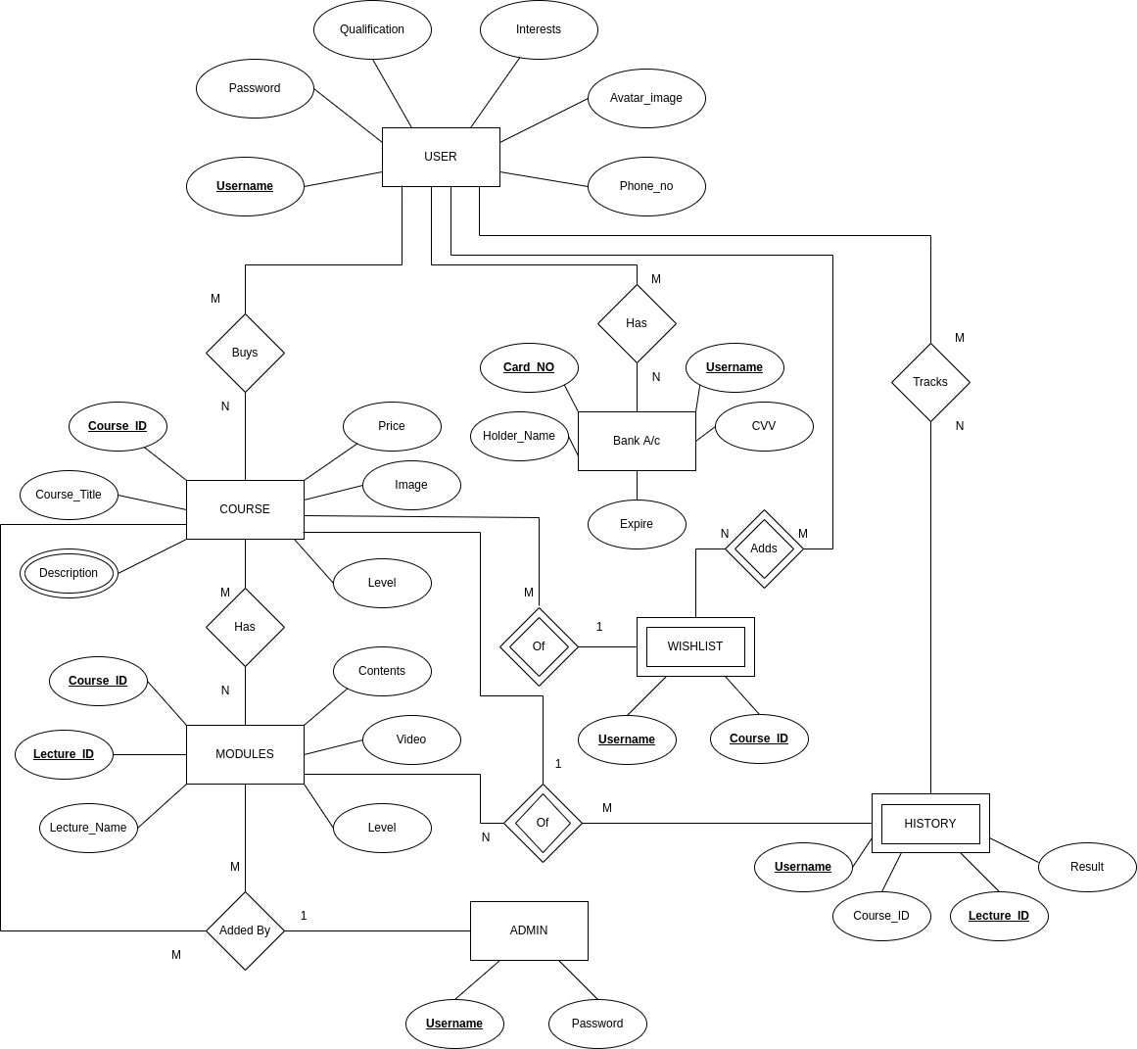

**3.2 Data flow diagram (level 0 and level 1)**

The Data Flow Diagrams (DFDs) are used for structure analysis and design. DFDs show the flow of data from external entities into the system. DFDs also show how the data moves and is transformed from one process to another, as well as its logical storage.

A data flow diagram (DFD) is a graphical representation of the "flow" of data through an information system, modelling its process aspects. A DFD is often used as a preliminary step to create an overview of the system, which can later be elaborated. DFDs can also be used for the visualization of data processing (structured design).It does not show information about the timing of process or information about whether processes will operate in sequence or in parallel (which is shown on a flowchart).

**Theory:**

**Data flow diagram example**:

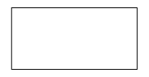**Entity**

This Represents an **Entity.** A source of data or a destination for data.

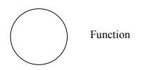**Process/Function**

**Process**: Represented by circles in the diagram. Processes are responsible for manipulating the data. They take data as input and output an altered version of the data.

**Database**

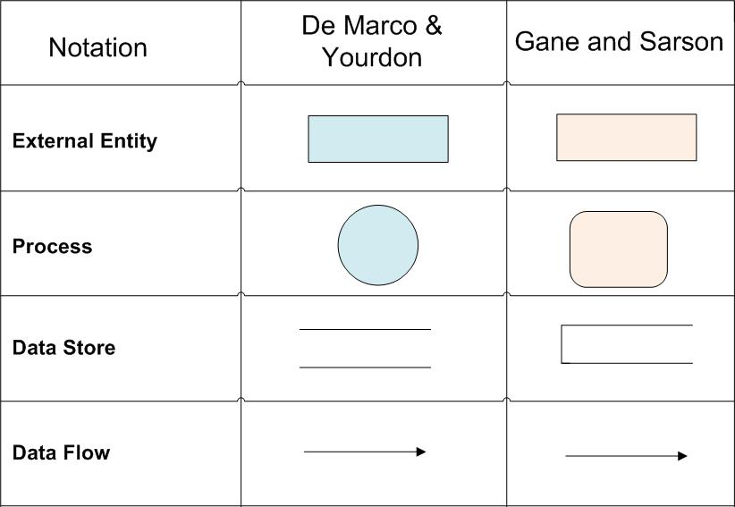

**Database:** Represented by a segmented rectangle with an open end on the right. Data Stores are both electronic and physical locations of data. Examples include databases, directories, files, and even filing cabinets and stacks of paper.

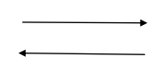**Data Flow**

**Data Flow Direction**: Represented by a unidirectional arrow. Data Flows show how data is moved through the System. Data Flows are labelled with a description of the data that is being passed through it.

Data flow diagrams are also known as **bubble charts**. DFD is a designing tool used in the top-down approach to Systems Design. This context-level DFD is next "exploded", to produce a Level 1 DFD that shows some of the detail of the system being modelled. The Level 1 DFD shows how the system is divided into sub-systems (processes), each of which deals with one or more of the data flows to or from an external agent, and which together provide all of the functionality of the system as a whole. It also identifies internal data stores that must be present.In order for the system to do its job, and shows the flow of data between the various parts of the system. In the course of developing a set of levelled data flow diagrams the analyst/designer is forced to address how the system may be decomposed into component sub-systems, and to identify the transaction data in the data model.

**Level-0 DFD**.

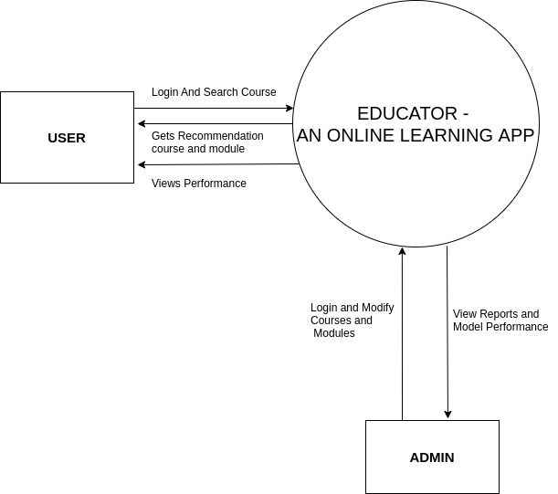

**Level 1 DFD.**

Level 1 DFD ‘s aim to give an overview of the full system. They look at the system in more detail. Major processes are broken down into sub-processes. Level 1 DFD ‘s also identifies data stores that are used by the major processes. When constructing a Level 1 DFD, we must start by examining the Context Level DFD. We must break up the single process into its sub-processes. We must then pick out the data stores from the text we are given and include them in our DFD. Like the Context Level DFD‘s, all entities, data stores and processes must be labelled. We must also state any assummade from the text.

**Level 1 DFD (FOR ADMIN)**

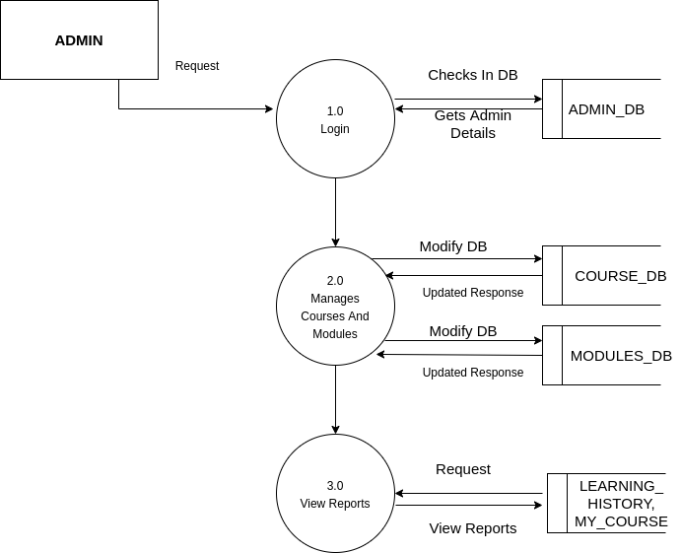

**DFD LEVEL -1 (FOR USER)**

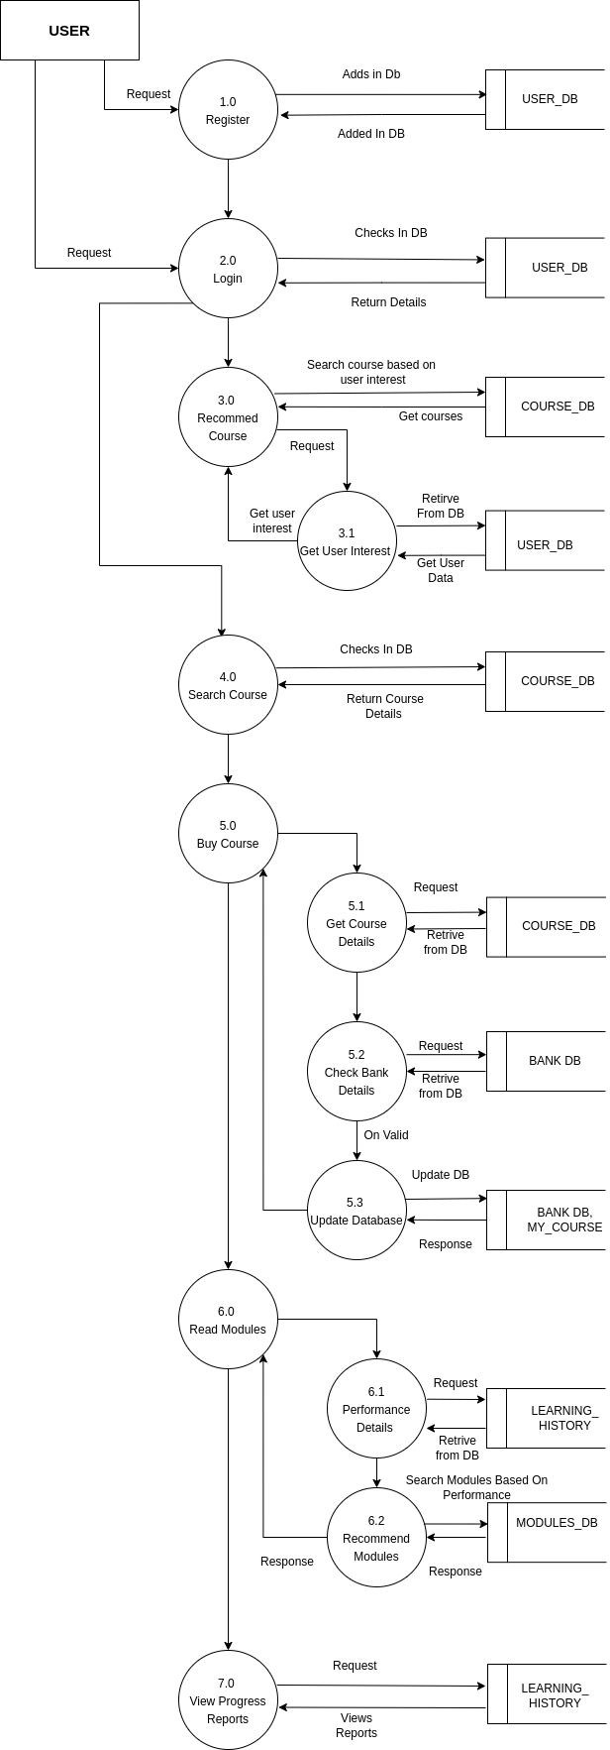

**3.3 Activity Diagram**

This Module Provides All The Activity Provided in The App. An activity diagram portrays the control flow from a start point to a finish point showing the various decision paths that exist while the activity is being executed. We can depict both sequential processing and concurrent processing of activities using an activity diagram.

They are used in business and process modelling where their primary use is to depict the dynamic aspects of a system. Flowcharts were typically invented earlier than activity diagrams. Non-programmers use Flow charts to model workflows. For example: A manufacturer uses a flow chart to explain and illustrate how a particular product is manufactured. We can call a flowchart a primitive version of an activity diagram. Business processes where decision making is involved is expressed using a flow chart.

**Admin Activity Diagram**

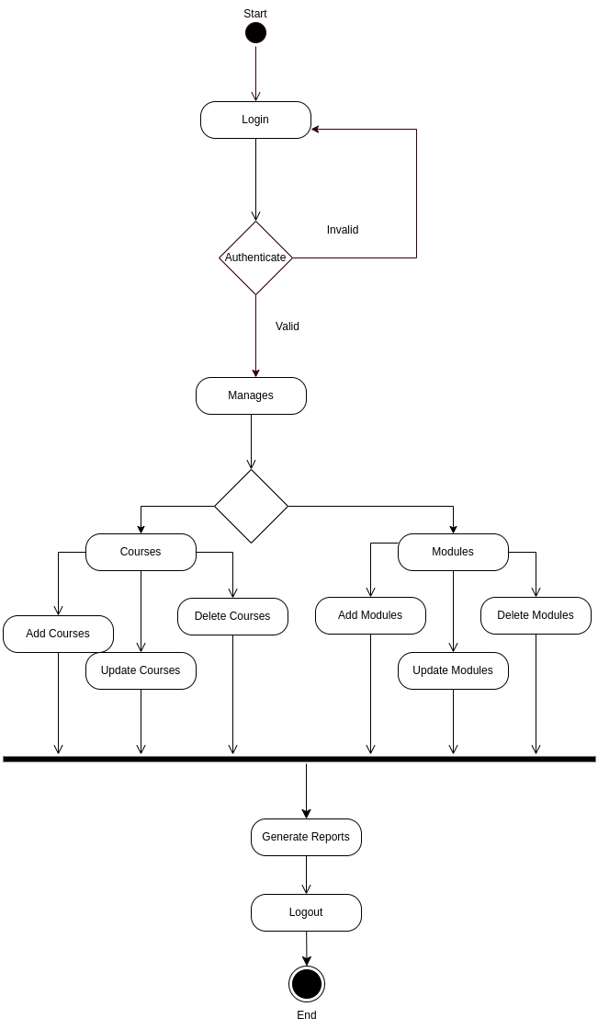

**User Activity Diagram**

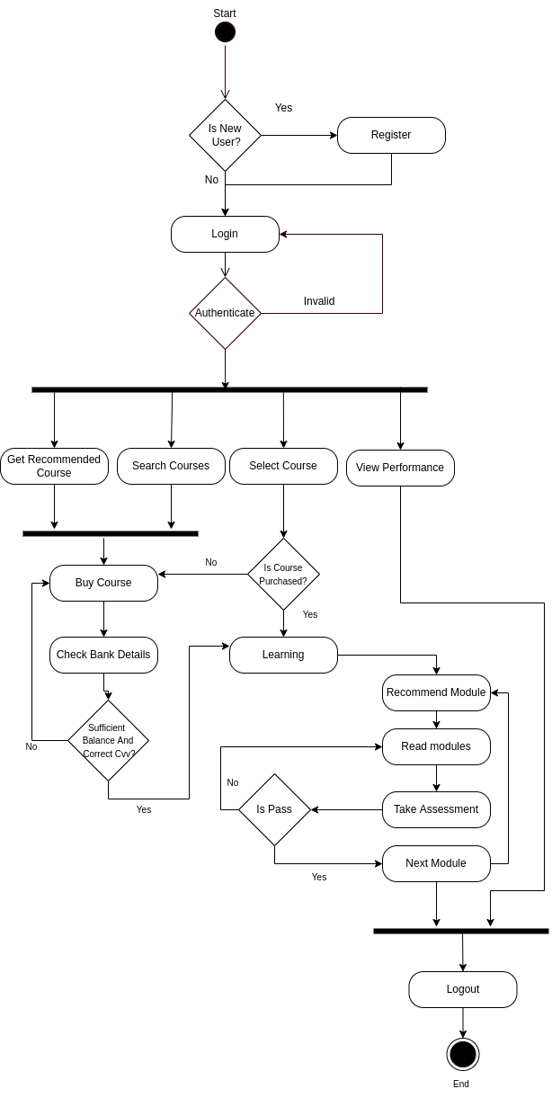

**3.4 GANTT CHART**

A Gantt chart is a type of bar chart, devised by Henry Gantt in the 1910s, that illustrates a project schedule. Gantt charts illustrate the start and finish dates of the terminal elements and summary elements of a project. Terminal elements and summary elements comprise the work breakdown structure of the project. Modern Gantt charts also show the dependency (i.e., precedence network) relationships between activities. Gantt charts can be used to show current schedule status using percent-complete shadings and a vertical "TODAY" line as shown here.

**GANTT CHART BENEFITS:**

**Clarity:** One of the biggest benefits of a Gantt chart is the tool's tool's ability to boil down multiple tasks and timelines into a single document. Stakeholders throughout an organization can easily understand where teams are in a process while grasping the ways in which independent elements come together toward project completion.

**Communication:** Teams can use Gantt charts to replace meetings and enhance other status updates. Simply clarifying chart positions offers an easy, visual method to help team members understand task progress.

**Time Management:** Most managers regard scheduling as one of the major benefits of Gantt charts in a creative environment. Helping teams understand the overall impact of project delays can foster stronger collaboration while encouraging better task organization.

**Efficiency:** Another one of the benefits of Gantt charts is the ability for team‘s members to leverage each other‘s deadlines for maximum efficiency. For instance, while one team member waits on the outcome of three other tasks before starting a crucial piece of the assignment, he or she can perform other project tasks.

**Accountability:** When project teams face major organizational change, documenting effort and outcomes becomes crucial to career success. Using Gantt charts during critical projects allows both project managers and participants to track team progress, highlighting both big wins and major failures.

**Gantt Chart**

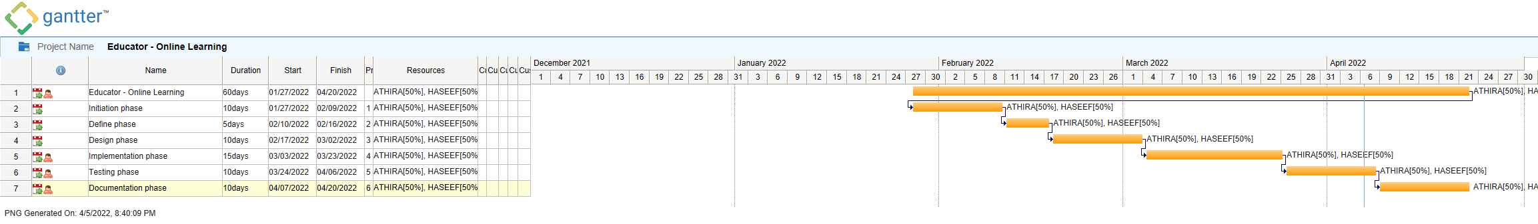

**3.5 Architecture Diagram**

An "Architecture" can be defined as an abstract description of entities in a system and the relationships between them. It involves a series of decision-making processes. The architecture is a structure and a vision. A "system architecture" is the embodiment of concepts and the distribution of the correspondences between the functions of things or information and formal elements. It defines the relationships among elements as well as between elements and the surrounding environment.

Building a sound architecture is a complex task and a great topic for us to discuss here. After you build an architecture, relevant parties must understand it and follow its dictates. An architectural diagram is a diagram of a system that is used to abstract the overall outline of the software system and the relationships, constraints, and boundaries between components. It is an important tool as it provides an overall view of the physical deployment of the software system and its evolution roadmap.

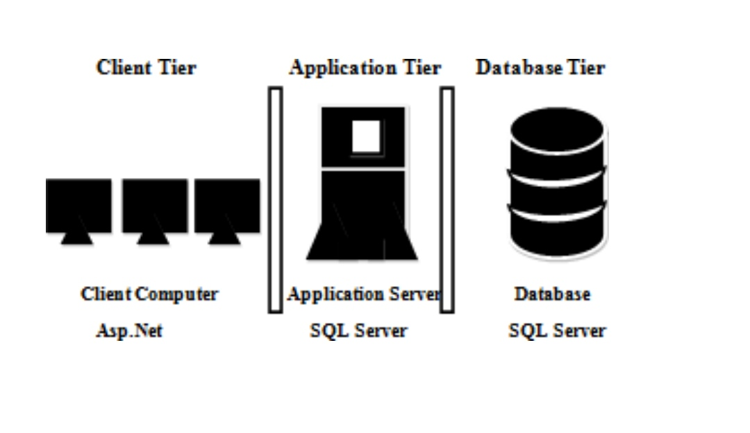

PYTHON FLASK

**3.6 Input/Output Design**

**Login and Register Page**

<!DOCTYPE html>

<html lang="en">

<head>

<script src="https://ajax.googleapis.com/ajax/libs/jquery/3.5.1/jquery.min.js"></script>

<link rel="stylesheet" href="https://cdn.jsdelivr.net/npm/bootstrap@4.6.1/dist/css/bootstrap.min.css" integrity="sha384-zCbKRCUGaJDkqS1kPbPd7TveP5iyJE0EjAuZQTgFLD2ylzuqKfdKlfG/eSrtxUkn" crossorigin="anonymous">

<script src="https://cdn.jsdelivr.net/npm/bootstrap@4.6.1/dist/js/bootstrap.min.js" integrity="sha384-VHvPCCyXqtD5DqJeNxl2dtTyhF78xXNXdkwX1CZeRusQfRKp+tA7hAShOK/B/fQ2" crossorigin="anonymous"></script>

<script src="https://cdn.jsdelivr.net/npm/bootstrap@4.6.1/dist/js/bootstrap.bundle.min.js" integrity="sha384-fQybjgWLrvvRgtW6bFlB7jaZrFsaBXjsOMm/tB9LTS58ONXgqbR9W8oWht/amnpF" crossorigin="anonymous"></script>

<meta charset="UTF-8">

<meta http-equiv="X-UA-Compatible" content="IE=edge">

<meta name="viewport" content="width=device-width, initial-scale=1.0">

<link rel="stylesheet" href="{{ url_for('static', filename= 'css/index.css') }}">

<title>Educator |Login </title>

</head>

<body>

<h1 class="Logo"> EDUCATOR</h1>

<span class="slogan">An Online Learning App</span>

<div class="login-wrap">

<div class="login-html">

<img src="/static/images/E-LOGO2.png" class="img-logo"/>

<input id="tab-1" type="radio" name="tab" class="sign-in" checked><label for="tab-1" class="tab">Sign

In</label>

<input id="tab-2" type="radio" name="tab" class="sign-up"><label for="tab-2" class="tab">Sign Up</label>

<div class="login-form">

<form action="/login" method="POST">

<div class="sign-in-htm">

<div class="group">

<label for="user" class="label">Username</label>

<input id="user" type="email" class="input" name="username" required="">

</div>

<div class="group">

<label for="pass" class="label">Password</label>

<input id="pass" type="password" class="input" data-type="password" name="password" required="">

</div>

<div class="group">

<input id="check" type="checkbox" class="check" checked>

<label for="check"><span class="icon"></span> Keep me Signed in</label>

</div>

<div>

{% with messages = get_flashed_messages(with_categories=true) %}

{% if messages %}

{% for category, message in messages %}

<div class="alert alert-warning" role="alert">{{ message }}</div>

{% endfor %}

{% endif %}

{% endwith %}

</div>

<div class="group">

<input type="submit" class="button" value="Sign In">

</div>

<div class="hr"></div>

<div class="foot-lnk">

<a href="{{url_for('admin_login')}}">Admin?</a>

</div>

</div>

</form>

<div class="sign-up-htm">

<div class="group">

<label for="pass" class="label">Repeat Password</label>

<input id="pass" type="password" class="input" data-type="password" name="conf_pass" required="">

</div>

<div class="group">

<input type="submit" class="button" value="Sign Up">

</div>

<div class="hr"></div>

<div class="foot-lnk">

<label for="tab-1">Already Member?</a>

</div>

</form>

</div>

</div>

</div>

</div>

</body>

</html>

**Home Page:**

{% extends 'base.html'%}

{% block title%}

HomePage

{% endblock %}

{% block home%}

active

{%endblock%}

{% block cssblock%}

<link rel="stylesheet" href="{{ url_for('static', filename= 'css/home.css') }}">

<!-- <link href="https://unpkg.com/aos@2.3.1/dist/aos.css" rel="stylesheet"> -->

{% endblock %}

{% block Bodyblock%}

<div class="Home-Content">

<div class="Top-Content">

<h1 class="Username-style">

Welcome {{session['username'].split('@').0 }}

</h1>

<div class="Content-top">

A Best Place For Online And Customized Studies.

<p>

Personalized learning is a teaching model based on that premise.

Each student gets a “learning plan” based on how they learn, what they know,

and what their skills and interests are. It’s the opposite of the “one size fits all”

approach used in most schools.

Students work with their teachers to set both short-term and long-term goals.

This process helps students take ownership of their learning.

</p>

</div>

<img src="/static/images/sitting.png" class="sitting" />

<img src="/static/images/miscellaneous.png" class="misc" />

</div>

<div class="second-top">

<img src="/static/images/SVG1.svg" class="svg_image_top" />

<h1 class="learning">

Let's Start With Your Learning ....

</h1>

<div class="Contents">

<div class=" row row-col-sm-6 card-container">

{%for i in courselist%}

<div class="card" data-aos="fade-up">

<img class="card-img-top" src="{{url_for('static', filename= 'images/courseimage/'+i.url) }}"

alt="Image Not Found....">

<div class="card-body">

<h5 class="card-title">{{i.course_title}}</h5>

<p class="card-text">{{i.description}}</p>

{% if i.registered %}

<a href="{{url_for('payment_course',course_id = i.id)}}"> <button class="btn btn-outline-success"> Buy @

RS {{i.price}} </button></a>

<button class="btn btn-outline-danger"> Add to Wishlist </button>

{% endif %}

</div>

</div>

{%endfor%}

</div>

</div>

</div>

</div>

{% endblock %}

\

**Modules Page**

{% extends 'base.html'%}

{% block title%}

Learning

{% endblock %}

{% block learning%}

active

{%endblock%}

{% block cssblock%}

<link rel="stylesheet" href="{{ url_for('static', filename= 'css/module.css') }}">

<link rel="stylesheet" href="https://cdnjs.cloudflare.com/ajax/libs/font-awesome/4.7.0/css/font-awesome.min.css">

{% endblock %}

{% block Bodyblock %}

<div class="top-content">

{%if data%}

<section>

<div class="heading ">

<h1 class="row">

{{subjectname}}

</h1>

<div class="cert" >

{% for i in data%}

{% if i[2] == 'Finaltest' %}

{% if i[7] != 0 %}

<button class="btn btn-lg btn-primary" onclick="show('{{i[0]}}')">View Certificate</button>

{% endif %}

{% endif %}

{% endfor %}

</div>

</div>

<div class="row ">

<div class="col-lg description">

description

<div class="row">

<div class="notes-details col-lg">

<video width="100%" height="100%" controls id="myVideo" src="/static/course_content/educator-front.mp4" type="video/mp4" >

Your browser does not support the video tag.

</video>

</div

</div>

{% with messages = get_flashed_messages(with_categories=true) %}

{% if messages %}

{% for category, message in messages %}

<div class="alert">{{ message }} <br>

<button type="button" class="close-btn" data-dismiss="alert" >

Okay

</button>

</div>

{% endfor %}

{% endif %}

{% endwith %}

</div>

<div class=" course-content col-lg">

<h1>

Modules

</h1>

<hr>

<div class="drop-down ">

{% set count = namespace(value=0) %}

{% for i in data%}

{% if i[2] == 'test' or i[2] == 'Finaltest' %}

{% if i[7] == 1 %} <a class="dropdown-item" href="{{url_for('test',testname=i[3],c_id=i[0],l_id=i[1])}}">{{i[3]}} <i class="fa fa-check" style="font-size:24px; color: rgb(80, 245, 80);"></i></a>

{%else%} <a class="dropdown-item" href="{{url_for('test',testname=i[3],c_id=i[0],l_id=i[1])}}">{{i[3]}} <i class="fa fa-edit" style="font-size:24px"></i></a>

{% endif %}

{%else%}

{% if i[7] == 0 %}

{% set count.value = count.value + 1 %}

{%else%}

<a class="dropdown-item" onclick="playvideo('{{i[5]}}','{{i[0]}}', '{{i[1]}}' )">{{i[3]}} <i class="fa fa-check" style="font-size:24px; color: rgb(80, 245, 80);"></i> </a>

{% endif %}

{% endif %}

{% endfor %}

</div>

{% endif %}

</div>

</section>

{%else%}

<section>

An Error Occured Try Again Later...

</section>

{% endif %}

<script>

$.ajax({

type: "POST",

url: "/getcert_id",

data:JSON.stringify({"c_id":cid}),

contentType: "application/json",

dataType: 'json',

success: function(result) {

// Location.reload()

let id = result['id']

window.location.href = "/viewcertificate/"+id

}

});

}

$("#myVideo").bind("ended", function() {

location.reload()

});

</script>

</div>

{% endblock %}

{% block javascript%}

<script src="/static/js/modules.js"></script>

{% endblock %}

**Payment Page**

{% extends 'base.html'%}

{% block title%}

Payment

{% endblock %}

{% block cssblock%}

<link rel="stylesheet" href="{{url_for('static',filename = 'css/payment_page.css')}}" />

{% endblock %}

{% block Bodyblock %}

<div class="payment_container">

<div class="heading">

<h1>

Checkout

</h1>

<div class="payment_details">

<div class="user_details">

<h3>

Purchased By.

<hr>

<br>

{{session['username']}}

</h3>

<div>

Details

</div>

</div>

<div class="product_details">

<div>

<h4>

Order Summary

</h4>

<hr>

</div>

</div>

</div>

{%set t = i.price | int %}

{% set tax = (t*10) /100 %}

<form action="/purchase/{{i.id}}" method="POST">

<div class="payment">

<h3>

Payment

</h3>

<hr><div class="card__front card__part">

<div class="card__space-75">

<img class="card__back-square card__square" src="/static/images/chip.png">

<img class="card__back-logo card__logo" src="/static/images/visa_logo.png">

</div>

</div>

</div>

{% endfor%}

{% endif %}

<div class="add-new">

<a href="{{ url_for( 'addcard',course_id = i.id ) }}"><button type="button"

class="Symbol">+</button></a>

Add new cards

</div>

</div>

</div>

<div>

<input type="hidden" value="{{t}}" name="price"/>

<input type="submit" class="btn btn-success btn-lg btn-block" value="Pay Now">

</div>

</form>

<div>

{% with messages = get_flashed_messages(with_categories=true) %}

{% if messages %}

{% for category, message in messages %}

<div class="alert alert-warning" role="alert">{{ message }}</div>

{% endfor %}

{% endif %}

{% endwith %}

</div>

</div>

<div class="bill">

<div class="details">

<p>Price</p>

<b>

<p> ₹{{i.price}}</p>

</b>

<p>Service Tax 10%</p>

<p>₹{{tax}}</p>

<h5>Sub-Total</h5>

<h5> ₹{{t + tax}}</h5>

<p> Discount</p>

<p>₹{{tax}}</p>

<h2 class="alert alert-success" role="alert">Total</h3>

<h2 class="alert alert-success" role="alert">₹{{i.price}}</h3>

</div>

</div>

</div>

</div>

{% endblock %}

**Admin Home**

<!DOCTYPE html>

<html lang="en">

<head>

<meta charset="UTF-8">

<meta http-equiv="X-UA-Compatible" content="IE=edge">

<meta name="viewport" content="width=device-width, initial-scale=1.0">

<script src="https://ajax.googleapis.com/ajax/libs/jquery/3.5.1/jquery.min.js"></script>

<link rel = "shortcut icon" href="/static/images/favicon.ico"/>

<title>Educator | Admin</title>

</head>

<body>

<nav class="navbar">

<a class="navbar-brand" href="#">

<h1 class="Logo"> EDUCATOR</h1>

<span class="slogan">An Online Learning App</span>

</a>

</nav>

<div class="Message">

{% with messages = get_flashed_messages(with_categories=true) %}

{% if messages %}

{% for category, message in messages %}

<div class="alert alert-warning" role="alert">{{ message }}

<button type="button" class="close" data-dismiss="alert" aria-label="Close">

<span aria-hidden="true">&times;</span>

</button>

</div>

{% endfor %}

{% endif %}

{% endwith %}

</div>

<section class="Options">

<img src="/static/images/courseimage/bf2.jpg"/>

</div>

<div>

<h4>

Welcome Admin

</h4>

</div>

</div>

<div class="menuoptions">

<button id ="Home" class="active-menu"><i class='fas fa-home' style='font-size:36px'></i> &nbsp; Home</button>

<button id ="Course" ><i class='fas fa-book-open' style='font-size:36px'></i> &nbsp; Course</button>

<button id ="Modules" ><i class='fas fa-puzzle-piece' style='font-size:36px'></i> &nbsp; Modules</button>

<button id ="Analize" ><i class='fas fa-poll' style='font-size:36px'></i> &nbsp; Insights</button>

<button id ="Modules" onclick=" window.location.href = '{{url_for('admin_login')}}'" > <i class="fa fa-sign-out" style="font-size:36px"></i> &nbsp; Logout</button>

</div>

</section>

<section class="Container">

</section>

</body>

var course_list = []

const course_fcn = (options)=>{

if (options == 'add'){

addpage(`{% include "admin/addcourse.html"%}`,"#Course")

$.ajax({

type: "GET",

url: "/getcoursecount",

success: function(result) {

let c_id = parseInt(result['c_id'])

if (isNaN(c_id)){

c_id = 0

}

$('#c_id').val(c_id)

}

});

} if (options == 'del'){

addpage(`{% include "admin/deletecourse.html"%}`,"#Course")

$.ajax({

type: "POST",

if (options == 'update'){

addpage(`{% include "admin/updatecourse.html"%}`,"#Course")

$.ajax({

type: "POST",

url: "/getcouorseno",

success: function(result) {

course_list = result['result']

for (let i in course_list)

{

$('#c_id').append('<option value="'+course_list[i][0]+'">'+course_list[i][0]+'</option>')

}

}

});

}

}

var course_list = []

const Modules_fcn = (options)=> {

if (options =='Add'){

addpage(`{% include "admin/admin_addmodules.html"%}`,"#Modules")

$.ajax({

type: "POST",

url: "/getcouorseno",

success: function(result) {

course_list = result['result']

for (let i in course_list)

{

$('#c_id').append('<option value="'+course_list[i][0]+'">'+course_list[i][0]+'</option>')

}

}

});

}

if (options =='del'){

addpage(`{% include "admin/admin_deletemodules.html"%}`,"#Modules")

$.ajax({

type: "POST",

url: "/getcouorseno",

success: function(result) {

course_list = result['result']

for (let i in course_list)

{

$('#c_id').append('<option value="'+course_list[i][0]+'">'+course_list[i][0]+'</option>')

}

}

});

}

}

$('.question-paper').append(template)

times++;

$('#no_of_question').val(times)

}

const remove_question = ()=>{

times -= 1

$('#no_of_question').val(times)

$('.question-paper').children().last().remove();

}</script>

<script src="https://cdn.jsdelivr.net/npm/chart.js"></script>

<script src="/static/js/chart2.js"></script>

</html>

**Admin Course page**

<h3 class="heading"> Courses </h3>

<div class="Course-options">

<button class="opt" onclick="course_fcn('add')">

<h4>

Add Course

</h4>

</button>

<button class="opt" onclick="course_fcn('update')" >

<h4>

Update Course

</h4>

</button>

<button class="opt" onclick="course_fcn('del')">

<h4>

Delete Course

</h4>

</button>

</div>

**Admin Modules**

<h3 class="heading"> Modules</h3>

<div class="Course-options">

<button class="opt" id="AddModule" onclick="Modules_fcn('Add')">

<h4>

Add Module

</h4>

</button>

</a>

<button class="opt" id="DelModule" onclick="Modules_fcn('del')">

<h4>

Delete Module

</h4>

</button>

</div>

**Make Test Page**

<h3 class="heading">Make Test </h3>

<div class="modules-Details">

<form action="/addtest" method="POST" enctype="multipart/form-data">

<label>Lecture ID</label>

<input type="text" name="c_id" id='c_id' readonly required style="display: none;"/>

<input type="text" name="l_id" id='l_id' readonly required/>

<label>Question Paper name </label>

<input type="text" name="q_name" required />

<input type="text" name="no_of_question" value="1" id="no_of_question" />

<div>

<label>Select Paper type</label>

<select name="papertype">

<option value="test">Pre Course</option>

<option value="Finaltest">Final Test</option>

<option value="test">Other (Mid Term, etc)</option>

</select>

</div>

<div class="question-paper" name = "q-paper">

<div class="question">

<label>Write Question</label>

<input type="text" name="q0" id="q0" style="background-color: #015a7d;" required />

<label>Weights</label>

<select name="l0">

<option value="0">Easy</option>

<option value="1"> Average</option>

<option value="2">Difficult</option>

</select>

<div class="options-div">

<label>D:</label>

<input type="text" name="answer0" id="opt1" />

<input type="checkbox" value ='3' name='check0'/>

</div>

</div>

</div>

</div>

<button type="button" onclick="create_questiontemplate()" class="btn btn-block btn-outline-primary">Add Question</button>

<button type="submit" class="btn btn-block btn-outline-danger">Add Test</button>

</form>

</div>

**Insight Page**

<!DOCTYPE html>

<html lang="en">

<head>

<meta charset="UTF-8">

<meta http-equiv="X-UA-Compatible" content="IE=edge">

<meta name="viewport" content="width=device-width, initial-scale=1.0">

<link rel = "shortcut icon" href="/static/images/favicon.ico"/>

<title>Educator | Admin</title>

</head>

<body>

<nav class="navbar">

<a class="navbar-brand" href="#">

<h1 class="Logo"> EDUCATOR</h1>

<span class="slogan">An Online Learning App</span>

</a>

</nav>

<div class="Message">

{% with messages = get_flashed_messages(with_categories=true) %}

{% if messages %}

{% for category, message in messages %}

<div class="alert alert-warning" role="alert">{{ message }}

<button type="button" class="close" data-dismiss="alert" aria-label="Close">

<span aria-hidden="true">&times;</span>

</button>

</div>

{% endfor %}

{% endif %}

{% endwith %}

</div>

<div class="row">

<div class="col">

<div class="chart ">

<h5> Details </h5>

<div id="failed">

<div class="label-vals">

<label class="text-secondary">Color </label>

<label class="text-secondary"> lecture_id</label>

</div>

</div>

</div>

</div>

</div>

</div>

</section>

</body>

</html>

**Outputs:**

**Login.html**

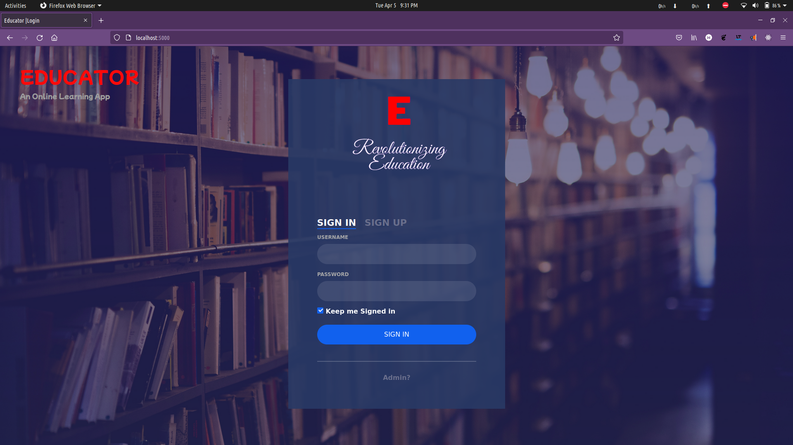

**Register.html:**

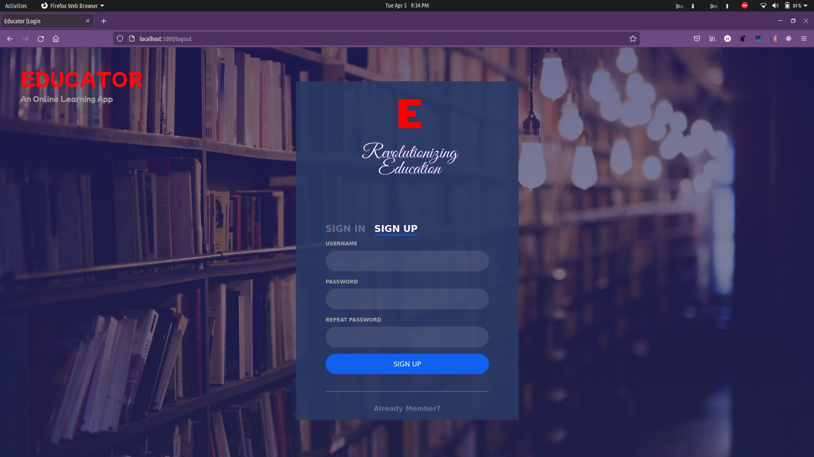

**Home.html**

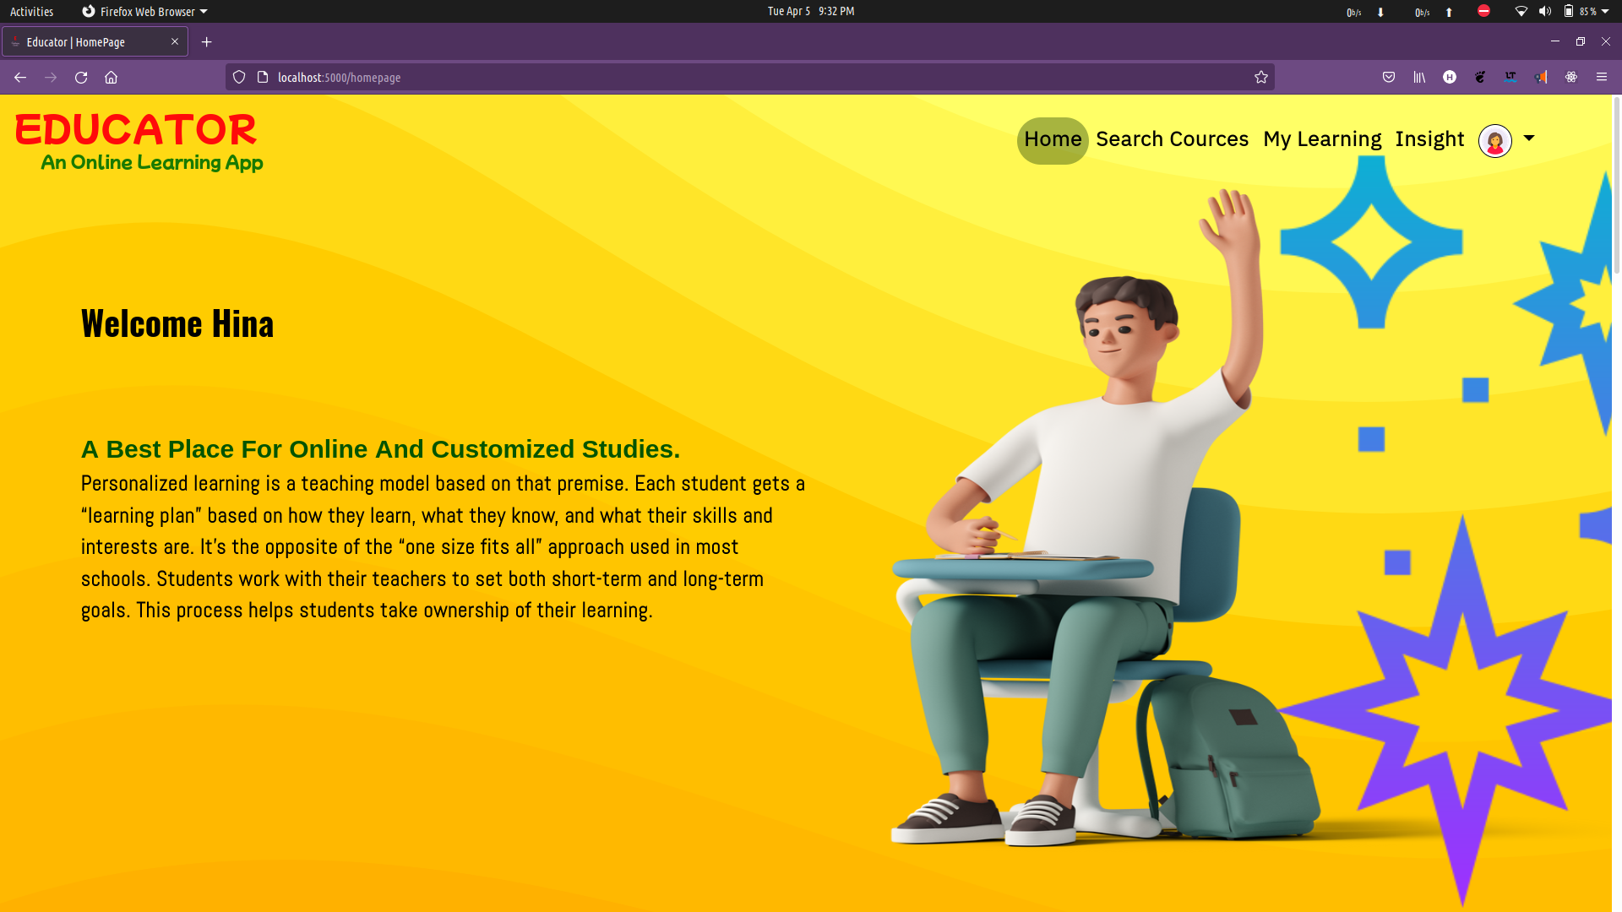

**Learning.html**



**Modules.html**

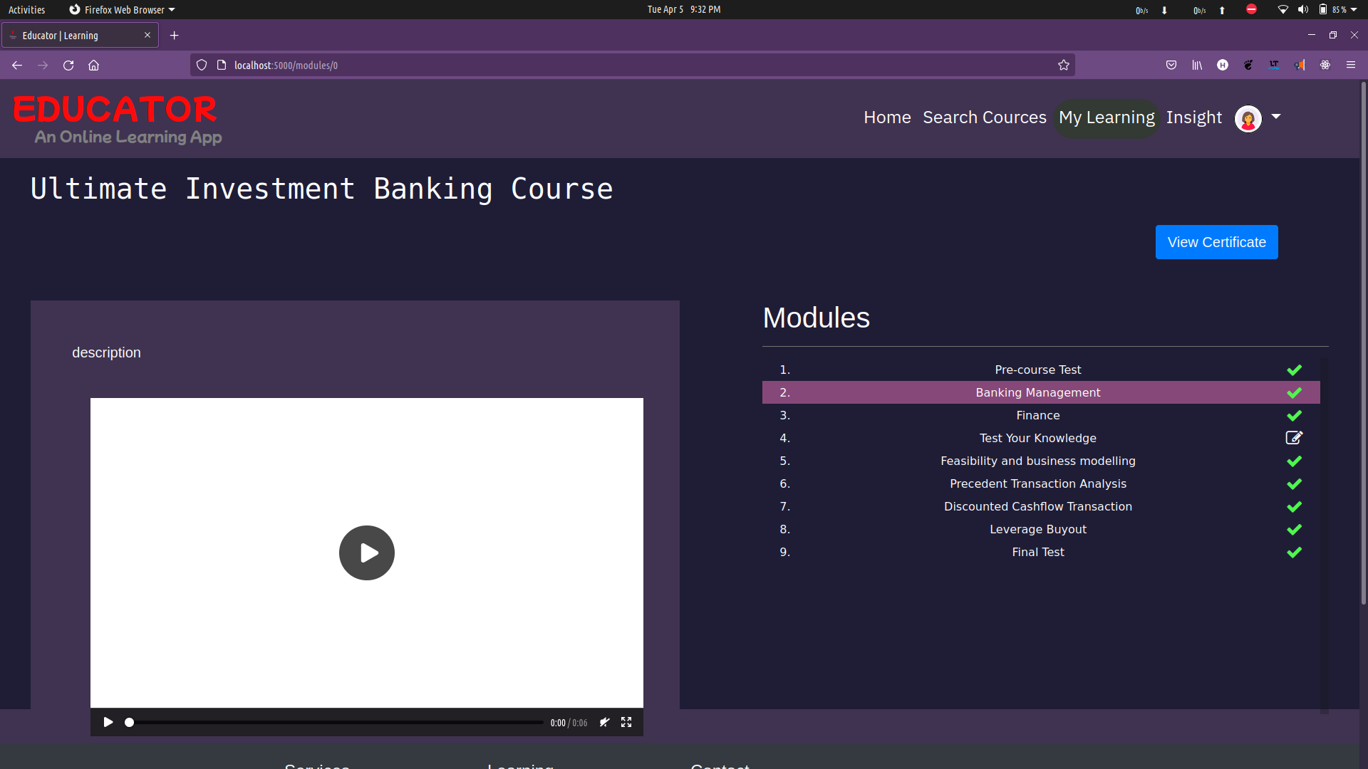

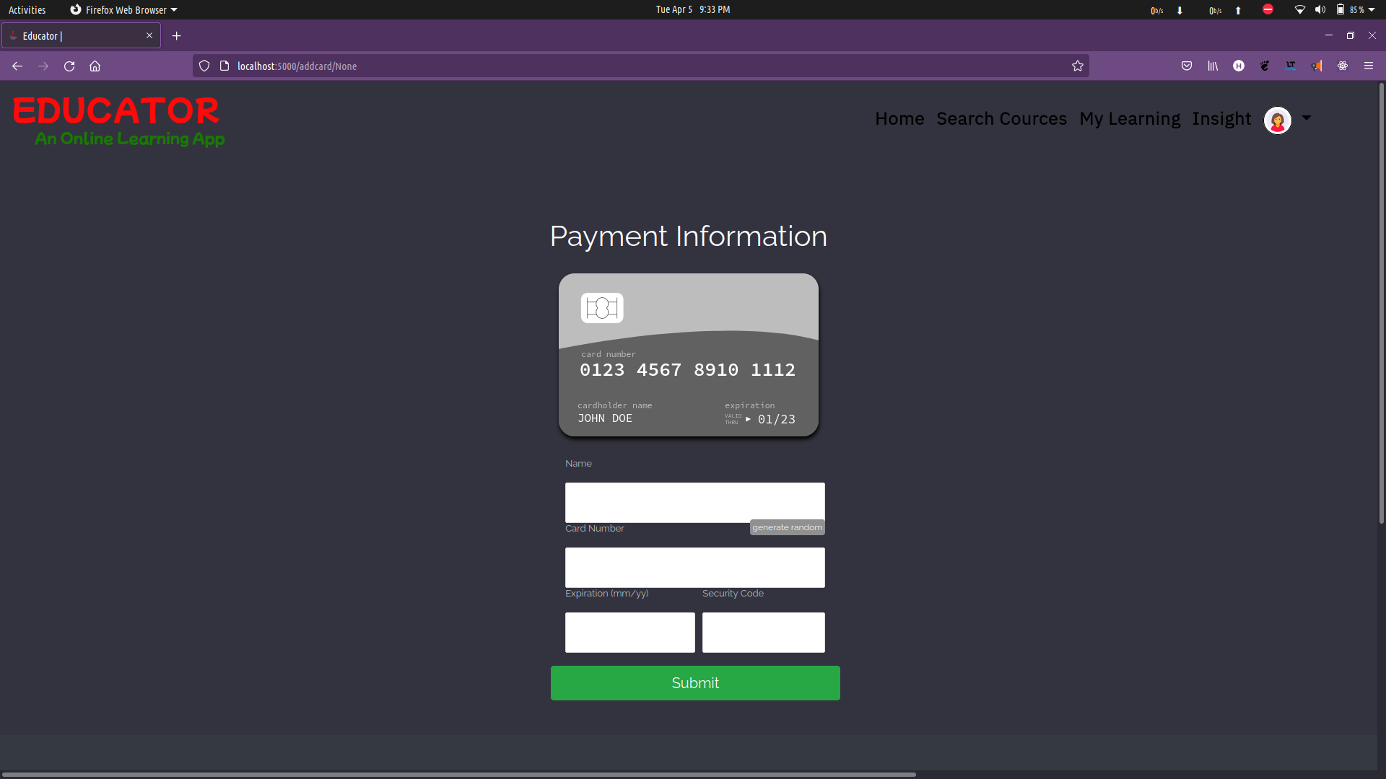**Payment.html**

**Admin.html**

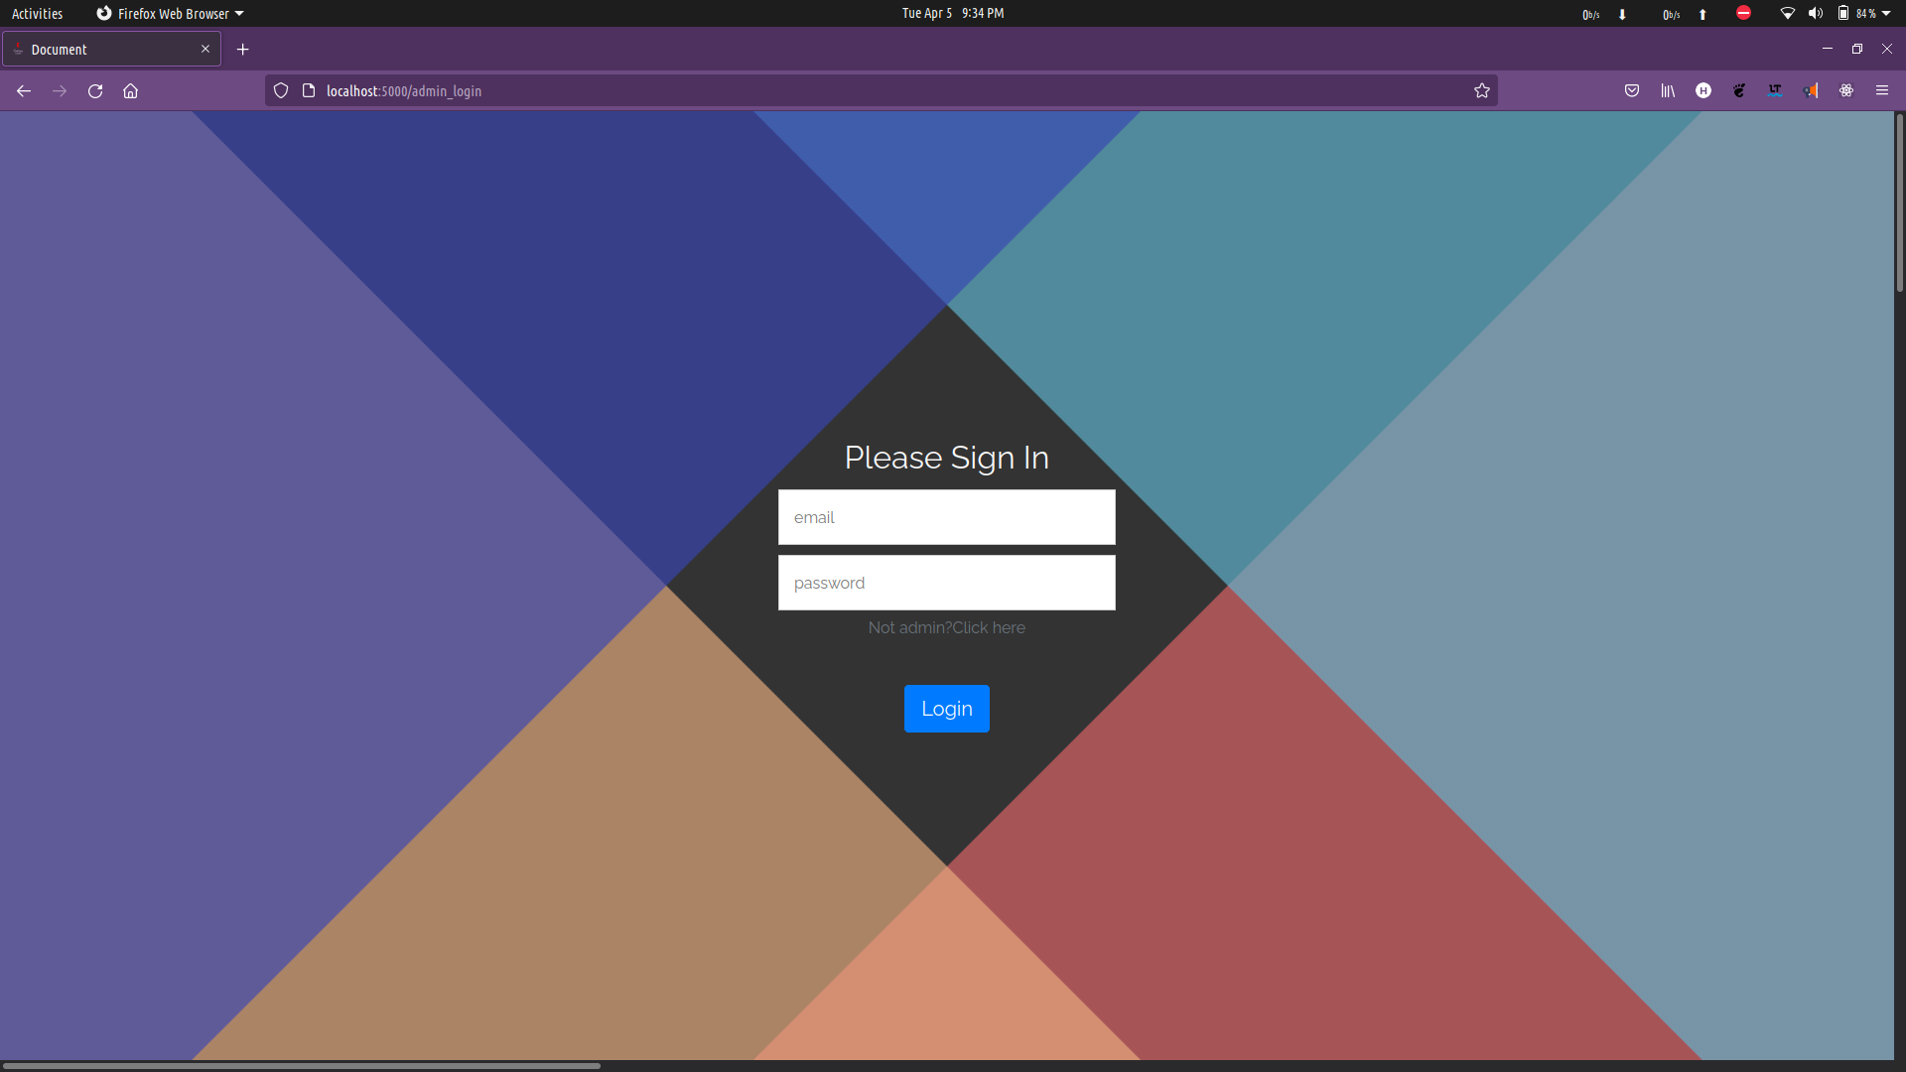

**Admin Home.html**

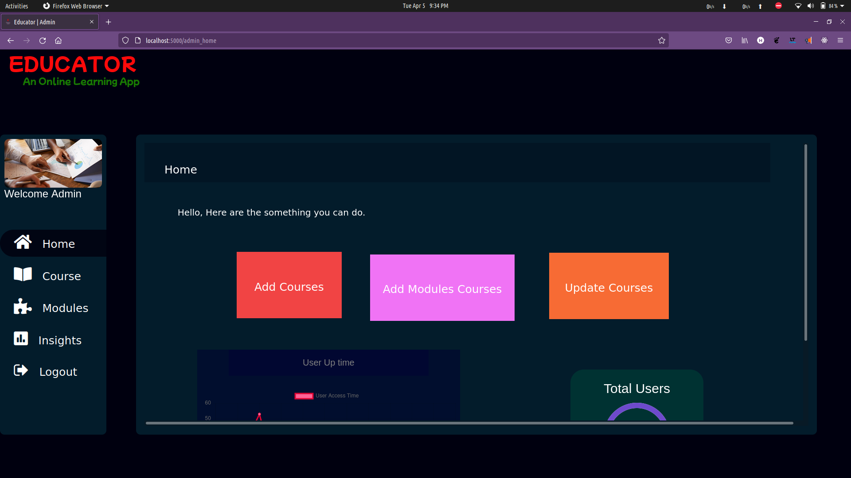

**AdminCourse.html**

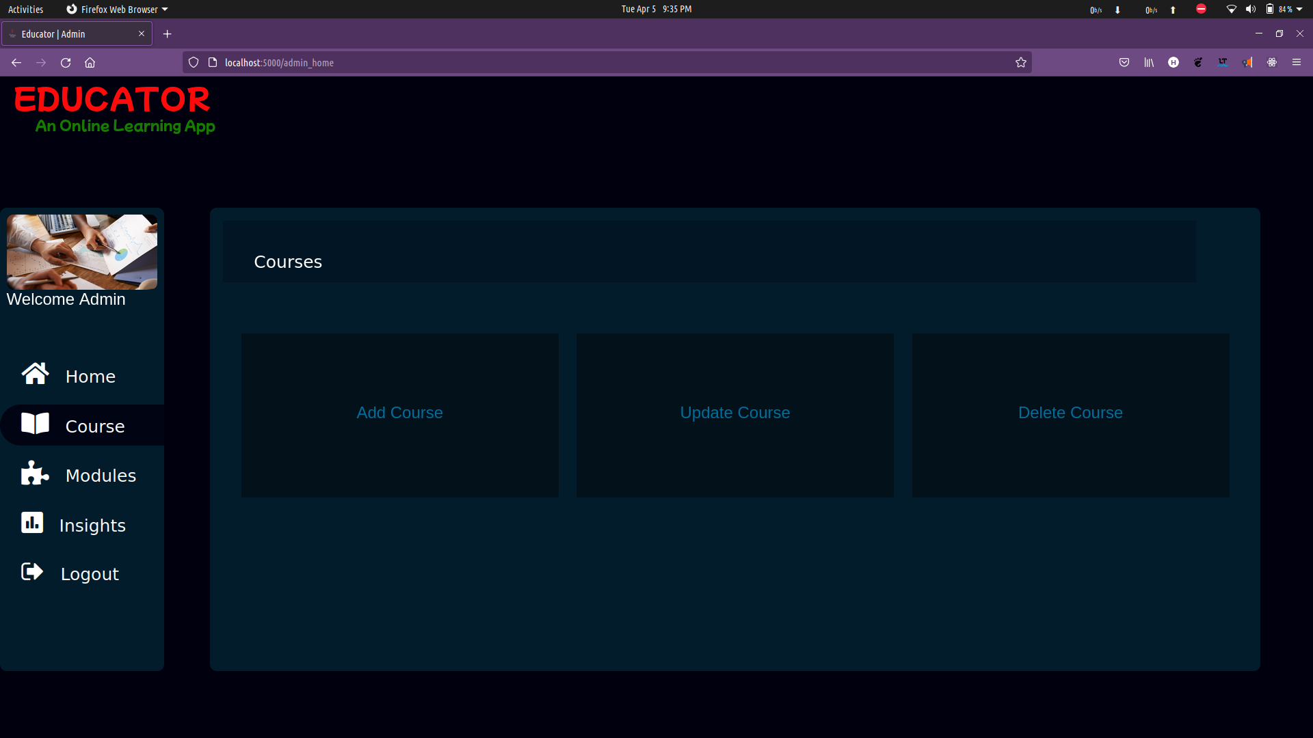

**AdminMakeTest.html**

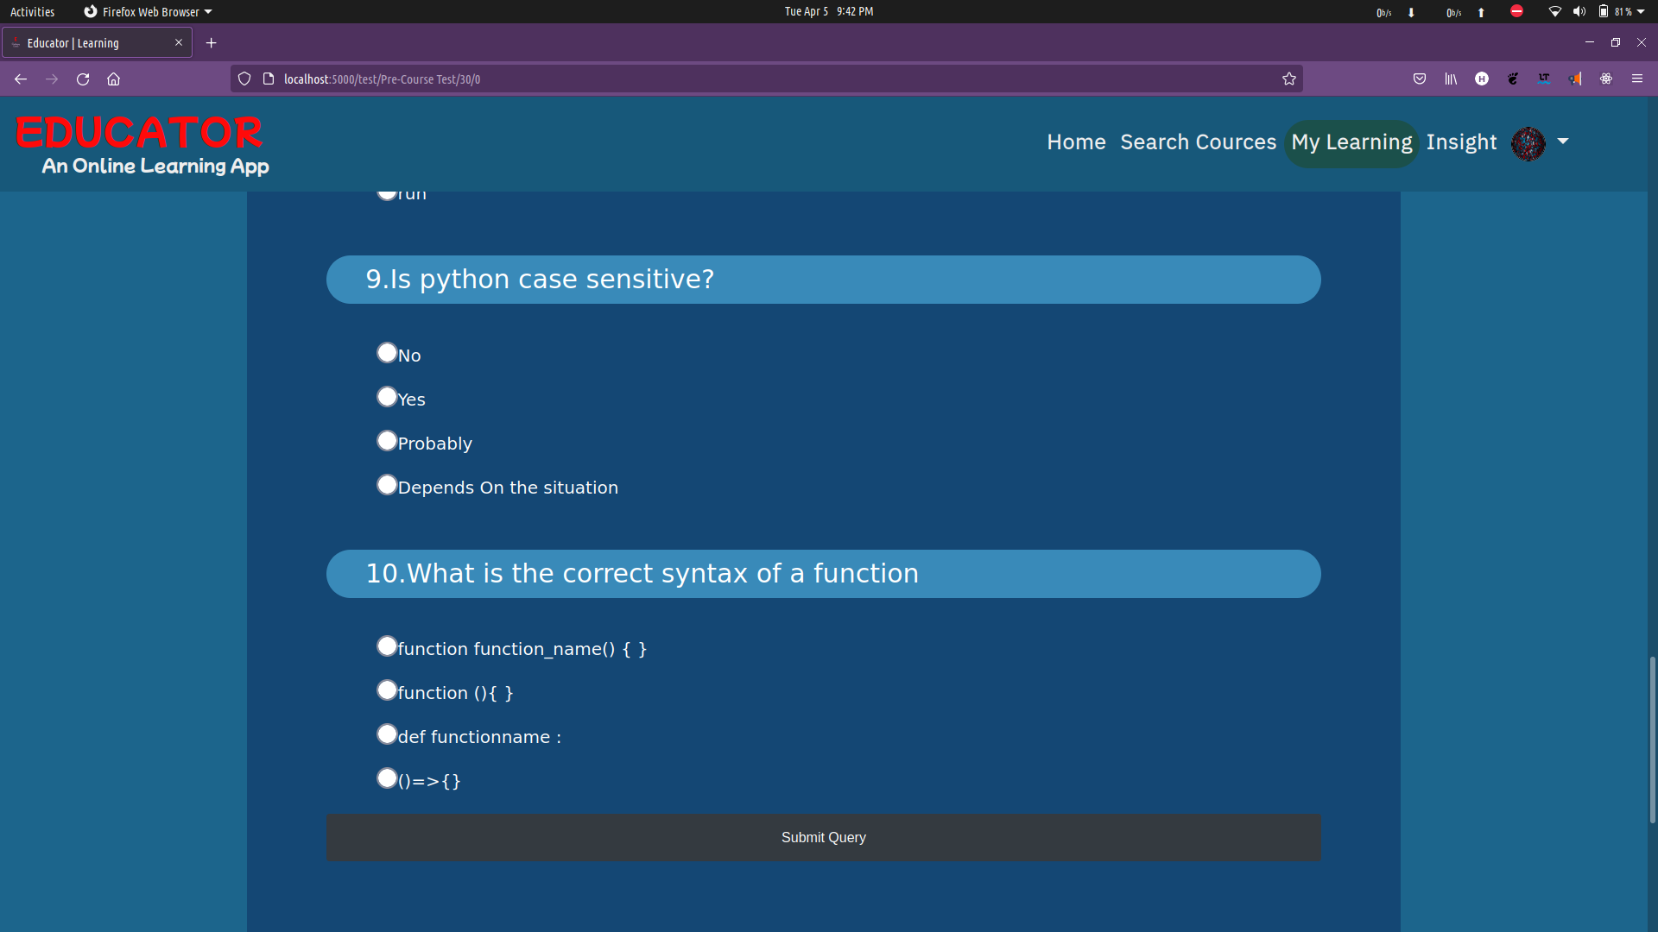

**4.SYSTEM CONFIGURATION**

**4.1 HARDWARE REQUIREMENTS**

|  |  |
| --- | --- |
| RAM | 4.00 GB AND ABOVE |
| HARD DISK | 256 GB AND ABOVE |
| PROCESSOR | INTEL i3 AND ABOVE |
| PROCESSOR SPEED | 2.06 GHz |

**4.2 SOFTWARE REQUIREMENTS**

|  |  |
| --- | --- |
| OPERATING SYSTEM | WINDOWS 10 , UBUNTU OS |
| PROGRAMMING LANGAUGE BACKEND FRAMEWORK | PYTHON FLASK, |
| FRONTEND FRAMEWORK | JINJA2,HTML,BOOTSTRAP |
| DATABASE | SQL SERVER |
| TOOL(S) | MICROSOFT PROJECT PLANNER, TEAM GANTT |
| DOCUMENTATION | MS WORD |

**5. DETAILS OF SOFTWARE**

**5.1 OVERVIEW OF FRONT END**

**JINJA2**

Jinja is a fast, expressive, extensible templating engine. Special placeholders in the template allow writing code similar to Python syntax. Then the template is passed data to render the final document. code and managed code.It includes:

1. Template inheritance and inclusion.
2. Define and import macros within templates.
3. HTML templates can use autoescaping to prevent XSS from untrusted user input.
4. A sandboxed environment can safely render untrusted templates.
5. Async support for generating templates that automatically handle sync and async functions without extra syntax.
6. I18N support with Babel.
7. Templates are compiled to optimized Python code just-in-time and cached, or can be compiled ahead-of-time.
8. Exceptions point to the correct line in templates to make debugging easier.
9. Extensible filters, tests, functions, and even syntax.

Jinja uses a central object called the template Environment. Instances of this class are used to store the configuration and global objects, and are used to load templates from the file system or other locations. Even if you are creating templates from strings by using the constructor of Template class, an environment is created automatically for you, albeit a shared one.Most applications will create one Environment object on application initialization and use that to load templates. In some cases however, it’s useful to have multiple environments side by side, if different configurations are in use.

The simplest way to configure Jinja to load templates for your application is to use PackageLoader.

**BOOTSTRAP**

Quickly design and customize responsive mobile-first sites with Bootstrap, the world’s most popular front-end open source toolkit, featuring Sass variables and mixins, responsive grid system, extensive prebuilt components, and powerful JavaScript plugins.

Originally created by a designer and a developer at Twitter, Bootstrap has become one of the most popular front-end frameworks and open source projects in the world.Bootstrap was created at Twitter in mid-2010 by @mdo and @fat. Prior to being an open-sourced framework, Bootstrap was known as Twitter Blueprint. A few months into development, Twitter held its first Hack Week and the project exploded as developers of all skill levels jumped in without any external guidance. It served as the style guide for internal tools development at the company for over a year before its public release, and continues to do so today.Originally released on Friday, August 19, 2011, we’ve since had over twenty releases, including two major rewrites with v2 and v3. With Bootstrap 2, we added responsive functionality to the entire framework as an optional stylesheet. Building on that with Bootstrap 3, we rewrote the library once more to make it responsive by default with a mobile first approach.

With Bootstrap 4, we once again rewrote the project to account for two key architectural changes: a migration to Sass and the move to CSS’s flexbox. Our intention is to help in a small way to move the web development community forward by pushing for newer CSS properties, fewer dependencies, and new technologies across more modern browsers.

Bootstrap is maintained by a small team of developers on GitHub. We’re actively looking to grow this team and would love to hear from you if you’re excited about CSS at scale, writing and maintaining vanilla JavaScript plugins, and improving build tooling processes for frontend code.

**5.2 OVERVIEW OF BACK-END**

**MICROSOFT SOL SERVER:**

Microsoft SQL Server is a relational database management system developed by Microsoft. As a database server, it is a software product with the primary function of storing and retrieving data as requested by other software applications—which may run either on the same computer or on another computer across a network (including the Internet).

Microsoft markets at least a dozen different editions of Microsoft SQL Server, aimed at different audiences and for workloads ranging from small single-machine applications to large Internet-facing applications with many concurrent users. The protocol layer implements the external interface to SQL Server. All operations that can be invoked on SQL Server are communicated to it via a Microsoft-defined format, called Tabular Data Stream (TDS).

• Enables you to implement a database with tables, columns and indexes.

• Guarantees the Referential Integrity between rows of various tables.

• Updates the indexes automatically.

• Interprets an SQL query and combines information from various tables.

**FLASK FRAMEWORK**

Flask is a micro web framework written in Python. It is classified as a microframework because it does not require particular tools or libraries. It has no database abstraction layer, form validation, or any other components where pre-existing third-party libraries provide common functions. However, Flask supports extensions that can add application features as if they were implemented in Flask itself. Extensions exist for object-relational mappers, form validation, upload handling, various open authentication technologies and several common framework related tools.

Flask was created by Armin Ronacher of Pocoo, an international group of Python enthusiasts formed in 2004.According to Ronacher, the idea was originally an April Fool's joke that was popular enough to make into a serious application.The name is a play on the earlier Bottle framework.When Ronacher and Georg Brandl created a bulletin board system written in Python in 2004, the Pocoo projects Werkzeug and Jinja were developed.In April 2016, the Pocoo team was disbanded and development of Flask and related libraries passed to the newly formed Pallets project.

**5.3 ABOUT THE PLATFORM**

**WINDOWS**

Windows is a series of Operating Systems developed by Microsoft. Each version of Windows includes a Graphical User Interface, with a desktop that allows users to view files and folders in Windows. For the past two decades, Windows has been the most widely used operating system for personal computers PCs. Microsoft Windows is designed for both home computing and professional purposes. Past versions of Windows home editions include Windows 3.0 (1990), Windows 3.1 (1992), Windows 95 (1995), Windows 98 (1998), Windows Me (2000), Windows XP (2001), and Windows Vista (2006). The current version, Windows 7, was released in 2009. The first business-oriented version of Windows, called Windows NT 3.1, was in 1993.

**UBUNTU-OS**

Ubuntu is a complete Linux operating system, freely available with both community and professional support. The Ubuntu community is built on the ideas enshrined in the Ubuntu Manifesto: that software should be available free of charge, that software tools should be usable by people in their local language and despite any disabilities, and that people should have the freedom to customize and alter their software in whatever way they see fit.Ubuntu will always be free of charge, and there is no extra fee for the “enterprise edition”, we make our very best work available to everyone on the same Free terms.Ubuntu includes the very best in translations and accessibility infrastructure that the Free Software community has to offer.

**6. TESTING**

Testing is a vital part of software development, and it is important to start it as early as possible, and to make testing a part of the process of deciding requirements. To get the most useful perspective on your development project, it is worthwhile devoting some thought to the entire lifecycle including how feedback from users will influence the future of the application. The tools and techniques we've discussed in this book should help your team to be more responsive to changes without extra cost, despite the necessarily wide variety of different development processes. Nevertheless, new tools and process improvements should be adopted gradually, assessing the results after each step.

Software development life cycle

Testing is a proxy for the customer. You could conceivably do your testing by releasing it into the wild and waiting for the complaints and compliments to come back. Some companies have been accused of having such a strategy as their business model even before it became fashionable:

• Tests represent requirements. Whether you write user stories on sticky notes on the wall, or use cases in a big thick document, your tests should be derived from and linked to those requirements. And as we've said, devising tests is a good vehicle for discussing the requirements.

• We're not done till the tests pass. The only useful measure of completion is when tests have been performed successfully.

Those principles apply no matter how you develop your software.

**Software Testing Types:**

**Unit testing** - Testing of individual software components or modules. Typically done by the programmer and not by testers, as it requires detailed knowledge of the internal program design and code, may require developing test driver modules or test harnesses.

**Integration testing** - Testing of integrated modules to verify combined functionality after integration. Modules are typically code modules, individual applications, client and server applications on a network, etc. This type of testing is especially relevant to client/server and distributed systems.

**Functional testing** - This type of testing ignores the internal parts and focus on the output is as per requirement or not. Black-box type testing geared to functional requirements of an application. System testing - Entire system is tested as per the requirements. Black-box type testing that is based on overall requirements specifications, covers all combined parts of a system.

**Load testing** - Its a performance testing to check system behavior under load. Testing an application under heavy loads, such as testing of a web site under a range of loads to determine at what point the system’s response time degrades or fails.

**Stress testing** - System is stressed beyond its specifications to check how and when it fails. Perform under heavy load like putting large number beyond storage capacity, complex database queries, continuous input to system or database load. Performance testing - Term often used interchangeably with ‘stress’ and ‘load’ testing. To check whether system meets performance requirements. Used different performance and load tools to do this.

**Install/uninstall testing** - Tested for full, partial, or upgrade install/uninstall processes on different operating systems under different hardware, software environment. Recovery testing - Testing how well a system recovers from crashes, hardware failures, or other catastrophic problems.

During The Progress Of The Application , Unit Testing ,Regression Testing , Performance Testing were used.

**Black box testing** - Internal system design is not considered in this type of testing. Tests are based on requirements and functionality.

**White box testing** - This testing is based on knowledge of the internal logic of an application’s code. Also known as Glass box Testing. Internal software and code working should be known for this type of testing. Tests are based on coverage of code statements, branches, paths, conditions.

**7. CONCLUSION AND FUTURE ENHANCEMENT**

**CONCLUSION**

This is an online learning platform in which students can learn any course at their own pace. It is different from other online learning platform. That it not only customize and recommend courses, but also it customizes modules / syllabus to each and every student with the help of Deep/Machine learning algorithms. In other online app. The content provided was vague and general to all student. It was not specific to a particular student group. But our app “Educator” Gives a customized learning experience which Increases productivity in learning by providing a learning roadmap to it.

**FUTURE ENHANCEMENT**

This project can provide beneficial impact on student behavior and their learning pattern. So eventually this enables us to provide a better roadmap to the student to study the course effectively.

The ML model use in this will assist to classify the students based on their check result and deliver them higher experience in learning. Student will finally voluntarily take Initiative to learn and enhance themselves.

**8.BIBLOGRAPHY**

**Book References:**

* **Flask:** Basics of Flask And Python To Develop Web App by Michelle Arman, Published by Sunrise Publisher

**Jinja2**: Essentials of Jinja by Sanjay Kumar, Published by Packt Publishing

* **SQL:** Introduction to SQL by Ramshaw Mask, Published by Dawn Publisher

**Web References:**

[**https://www.tutorialspoint.com**](https://www.tutorialspoint.com/)

[**https://www.javatpoint.com**](https://www.javatpoint.com/)

[**https://www.geeksforgeeks.com**](https://www.geeksforgeeks.com/)

**9.APPENDICES A-TABLE STRUCTURE**

**User_login**

|  |  |  |  |
| --- | --- | --- | --- |
| Name | Datatype | Constrants | Description |
| Username | varchar(50) | Primary key | Identifies User |
| Password | varchar(30) | Not null | User password |
| Phone No | varchar(10) | nullable | User Phone no |
| Interest | varchar(60) | nullable | User interest |
| User_Image | BLOB(500) | nullable | User image |

**Course_list**

|  |  |  |  |
| --- | --- | --- | --- |
| Name | Datatype | Constrants | Description |
| course_id | varchar(50) | Primary key | Unique course_id |
| Course title | varchar(30) | Not null | Course Title |
| Description | varchar(50) | Not Null | Course Description |
| Price | int | Not Null | Course Price |
| Image | BLOB(500) | Not Null | Course Image |
| Lecture_count | int | Not Null | Total Tecture |
| level | int | Not Null | Level of course |

**Modules**

|  |  |  |  |
| --- | --- | --- | --- |
| Name | Datatype | Constrants | Description |
| course_id | varchar(50) | Primary key | Unique module ID |
| lecture_id | varchar(50) | Primary Key | Unique Lecture ID |
| content | varchar(50) | Not Null | Course Content |
| video | varchar(500) | Not Null | Video Location |

**Student_History**

|  |  |  |  |
| --- | --- | --- | --- |
| Name | Datatype | Constrants | Description |
| username | varchar(50) | Foreign key | Unique User ID |
| course_id | varchar(50) | Not Null | Unique Course id |
| Lecture_id | varchar(50) | Foreign Key | Unique lecture id |
| Is_Completed | int | Not Null | Completed modules |
| Result | varchar(10) | Not Null | Result of lecture |

**Purchased Courses**

|  |  |  |  |
| --- | --- | --- | --- |
| Name | Datatype | Constrants | Description |
| username | varchar(50) | Foreign key | Unique user id |
| course_id | varchar(50) | Not Null | Unique course id |
| Is_Completed | int | Not Null | Completed Course |

**TestQuestion**

|  |  |  |  |
| --- | --- | --- | --- |
| Name | Datatype | Constrants | Description |
| course_id | varchar(50) | Primary Key | Unique course id |
| lecture_id | varchar(50) | Primary Key | Unique lecture id |
| Question | varchar(50) | Not Null | Question name |
| Answer | varchar(10) | Not Null | Answer of queston |
| Weights | int | Not Null | Weights of Question |
| Options | varchar(50) | Nullable | Options of question |

**Bank_Details**

|  |  |  |  |
| --- | --- | --- | --- |
| Name | Datatype | Constrants | Description |
| Username | varchar(50) | Primary Key | Unique user id |
| Card_NO | varchar(15) | Primary Key | User Card No |
| Cardholder_name | varchar(50) | Not Null | User Card Holder name |
| CVV | int(4) | Not Null | Card CVV number |
| Expire | Date | Not Null | Card Expiry |

**10.APPENDICES B-SCREENSHOTS**

**User Validation Module:**

**Login Page**



**Registration Page**



**Home Page**

**Course Page**

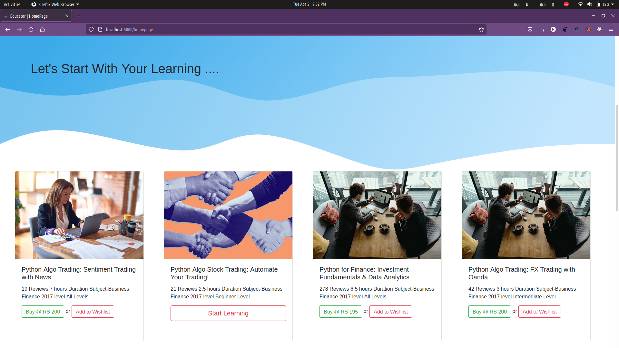

**Modules Page**

**Payment And Card 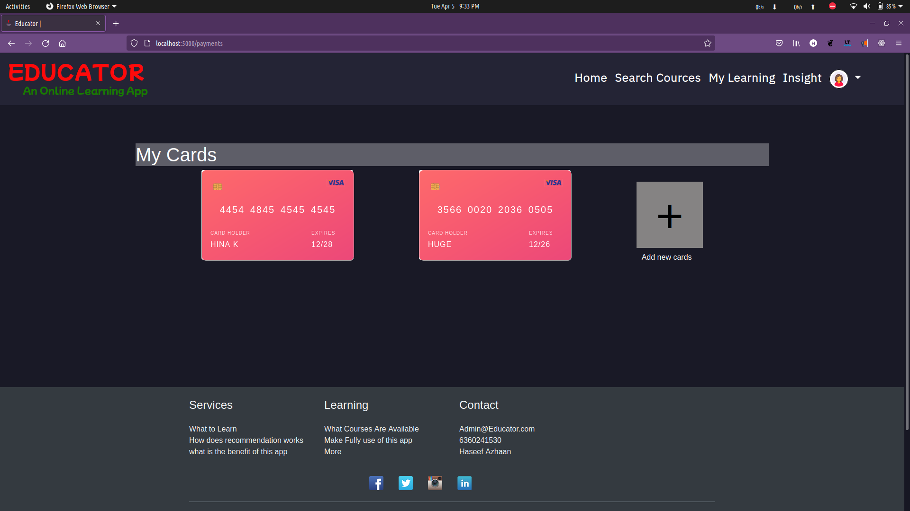 Page**

**Insight Page**

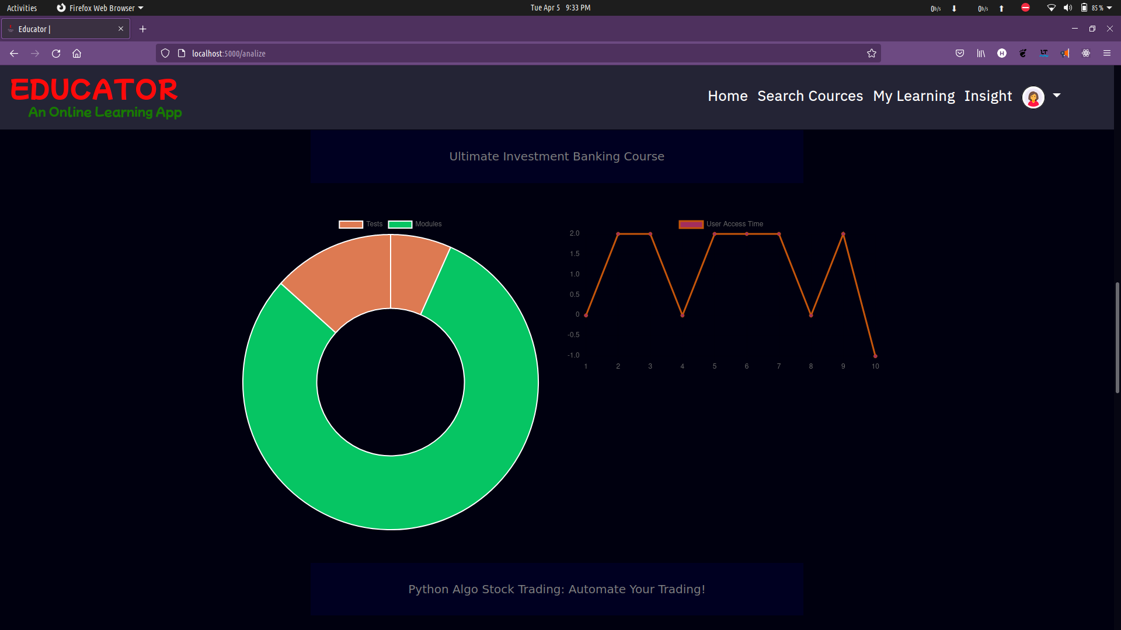

**Account Setting Page**

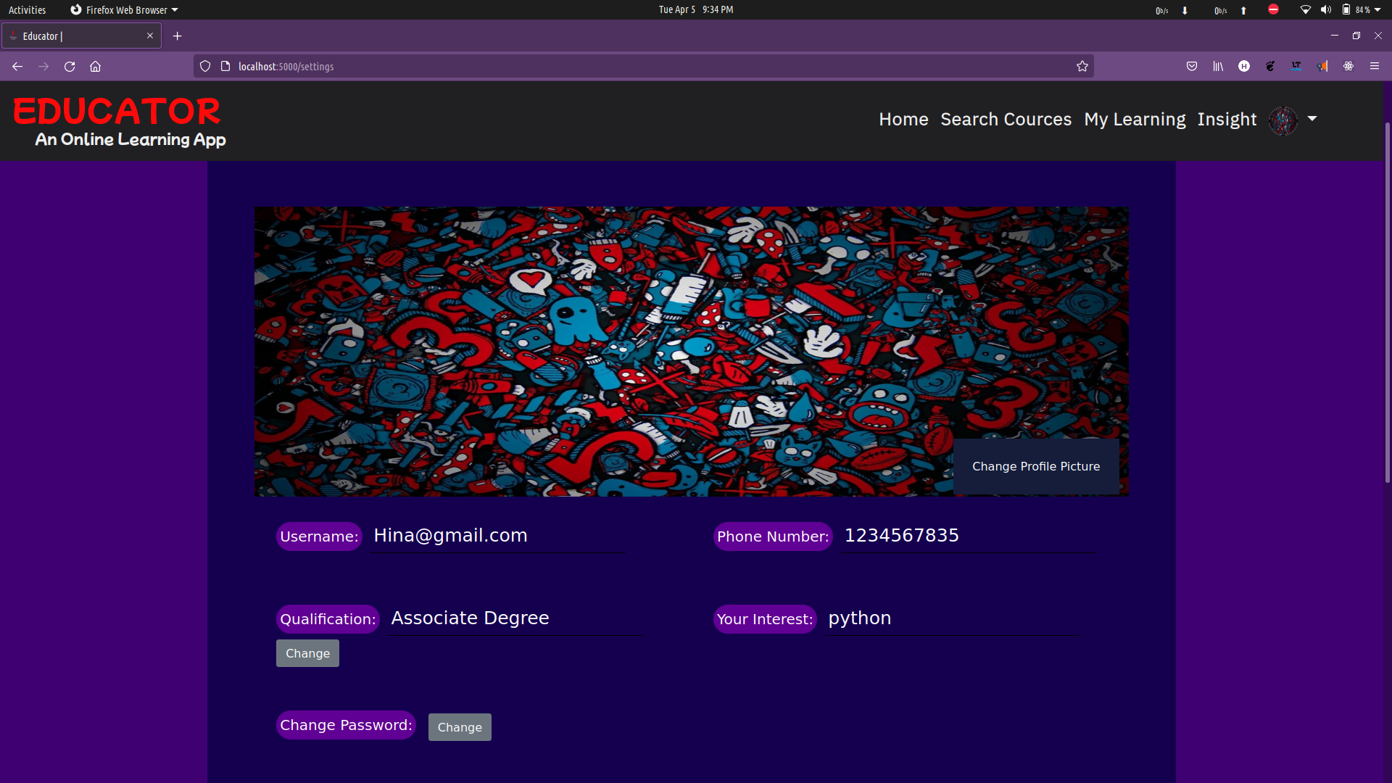

**Admin Home Page**

**Admin Add Course**

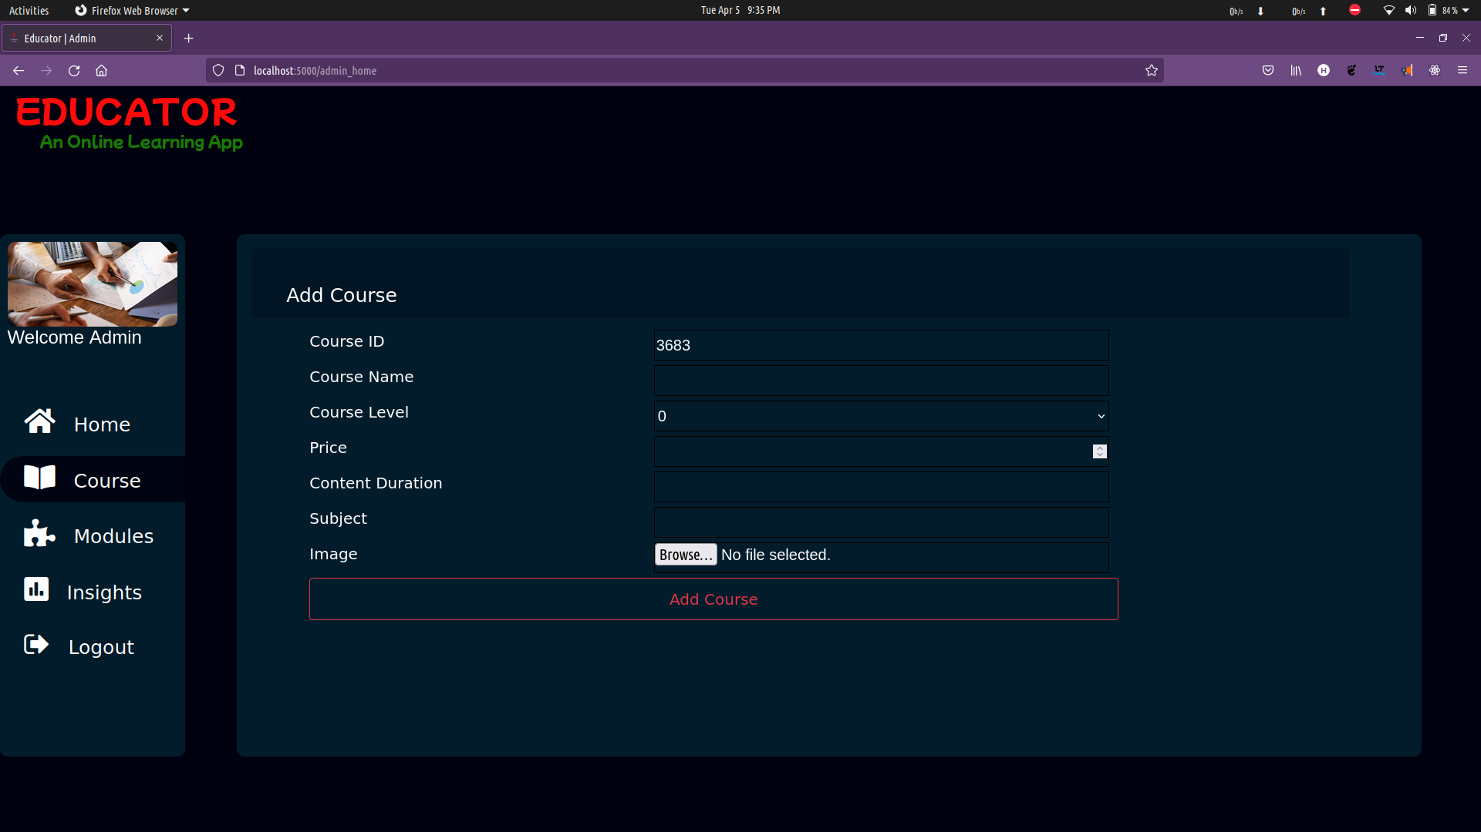

**Admin Update Course**

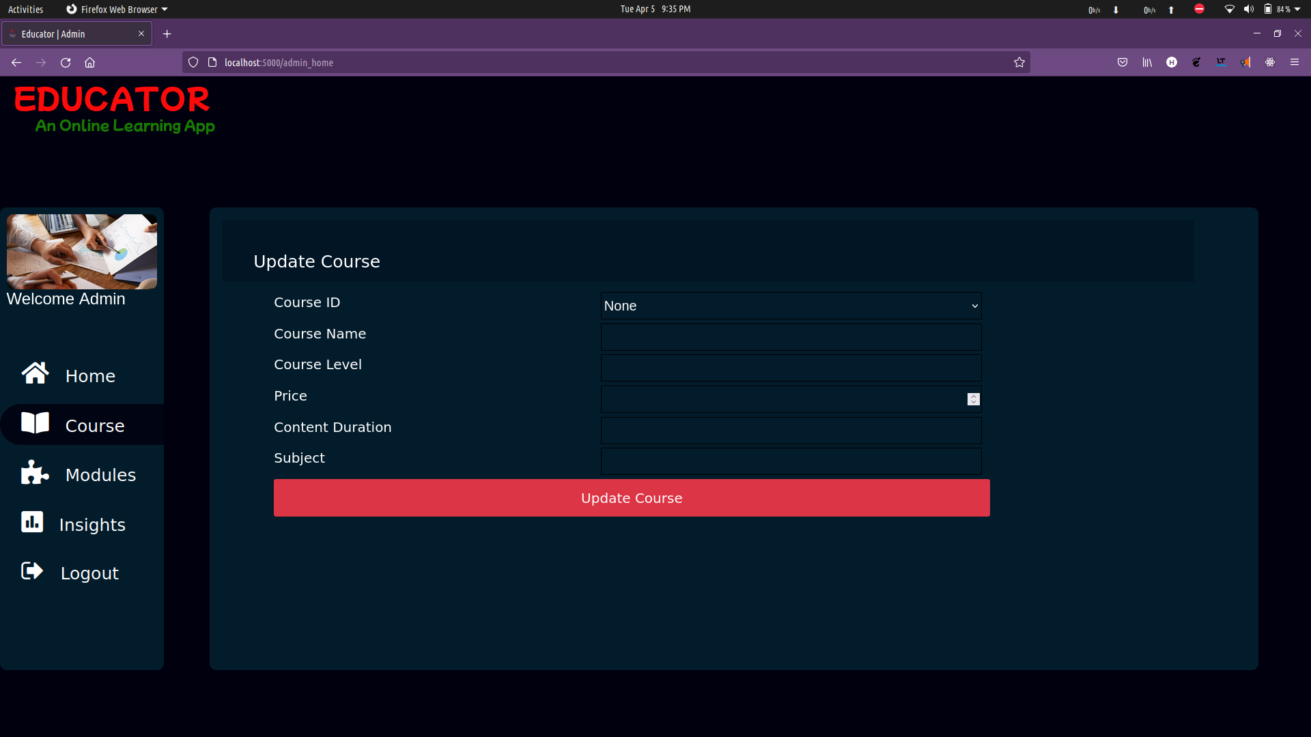

**Add Modules**

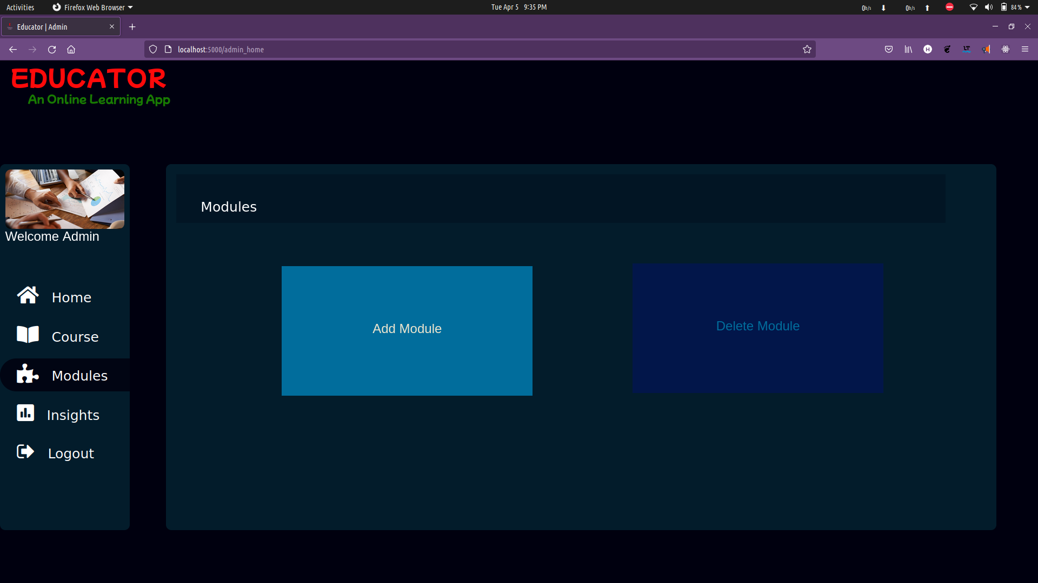

**Admin Insight Page**

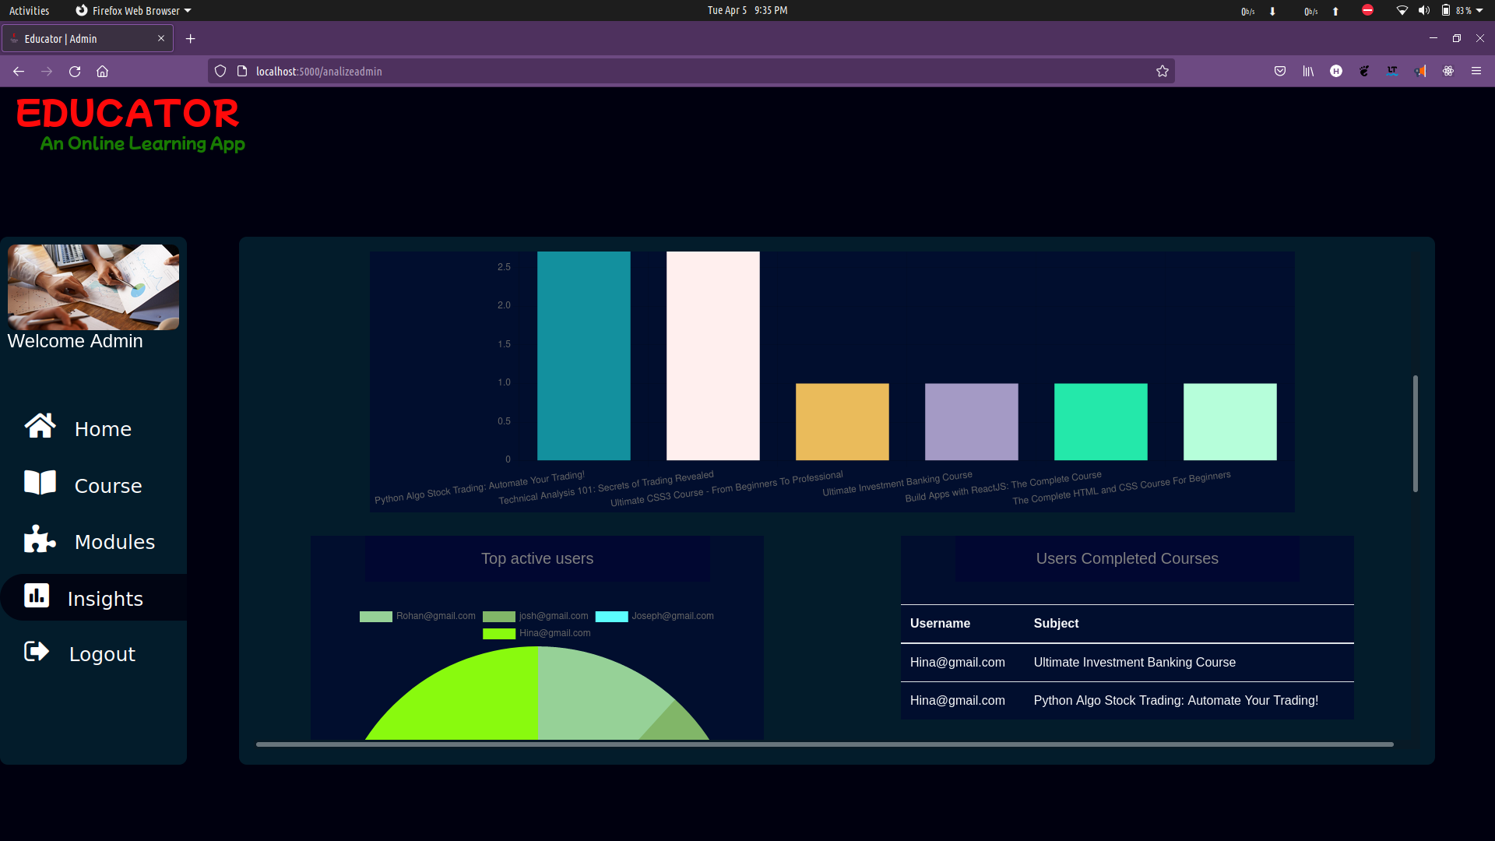**User Test Module**



**11.APPENDINCES C-SAMPLE REPORTS OF TEST CASES**

|  |  |  |  |  |  |  |  |
| --- | --- | --- | --- | --- | --- | --- | --- |
| **sl.no** | **Test Case Id** | **Test Description** | **Steps to Execute** | **Test Data** | **Expected Result** | **Actual Result** | **Status** |
| 01 | Test case id 1 | Correct username and password | Enters username and password in login form and clicks enter | Correct username and password | Successful login | Successful login | pass |
| 02 | Test case id 2 | Correct username and Wrong password | Enters username and password in login form and clicks enter | Correct username and Wrong password | Login Failed-Invalid Credentials | Login Failed-invalid Credentials | Pass |
| 03 | Test case id 3 | wrong username and correct password | Enters username and password in login form and clicks enter | Wrong username and Correct password | Login Failed-Invalid Credentials | Login Failed-invalid Credentials | Pass |
| 04 | Test case id 4 | wrong username and wrong password | Enters username and password in login form and clicks enter | Wrong username and Wrong password | Login Failed-Invalid Credentials | Login Failed-Invalid Credentials | Pass |
| 05 | Test case id 5 | Register New user | Enters Users Details | New User | registered Successfully | registered Successfully | Pass |
| 06 | Test case id 6 | Register Existing User | Enters Users Details | Existing User | User Already Exist – Recheck username | User Already Exist – Recheck username | Pass |
| 07 | Test case id 7 | Access Course List | Access a particular course | Click on start learning button | Display course modules | Display course modules | Pass |
| 08 | Test case id 8 | Purchase a course | Clicks on buy option | Enter correct card details | Course Purchased | Course Purchased | Pass |
| 09 | Test case id 9 | Purchase a course | Clicks on buy option | Enter Incorrect card details | Course-Not Purchased | Course-Not Purchased | Pass |
| 10 | Test Case id 10 | View Modules | Click on learning | Click on start learning button | View modules | View Modules | Pass |

**12.APPENDINCES D-Source Code**

**app.py**

from werkzeug.utils import secure_filename

from pathlib import Path

import os

from flaskext.mysql import MySQL

from flask import (Flask,render_template,request,flash, url_for, redirect, session, abort, jsonify )

import json

from datetime import date, datetime

from csv import writer

import csv

import uuid

from operator import itemgetter

# derived modules

from MlModels.course_recommendation import recommend

from backend import searchcourse

from backend.get_data import coursedata, create_course_data, create_cards_details, deduct_balance, mycourses

app = Flask(__name__)

app.config['MYSQL_DATABASE_USER'] = 'root'

# app.config['MYSQL_DATABASE_PASSWORD'] = 'root'

app.config['MYSQL_DATABASE_DB'] = 'project'

app.config['MYSQL_DATABASE_HOST'] = 'localhost'

app.secret_key = b'_5#y2L"F4Q8z\n\xec]/'

app.config['UPLOAD_FOLDER'] = 'static/modules'

app.config['UPLOAD_FOLDER_IMAGE'] = 'static/images/courseimage'

app.config['UPLOAD_EXTENSIONS'] = ['.MP4', '.mp4', '.jpg', '.png']

app.config['CSVFILE'] = 'dataset'

mysql = MySQL(app)

conn = mysql.connect()

cursor = conn.cursor()

@app.route('/', methods=('GET', 'POST'))

def indexpage():

return render_template("index.html")

@app.route("/homepage", methods=['POST', 'GET'])

def homepage():

try:

if session['username']:

return render_template("home.html", courselist=create_course_data(conn, session['username']))

else:

return redirect(url_for("indexpage"))

except KeyError as k:

return redirect(url_for("indexpage"))

@app.route('/logout', methods=['POST', 'GET'])

def logout():

session.pop("username", None)

return render_template("index.html")

@app.route('/login', methods=('POST', 'GET'))

def login_creds():

if request.method == 'POST':

uname = request.form.get('username')

password = request.form.get('password')

cursor.execute(

f"SELECT count(*) FROM userlogin WHERE username = '{uname}'AND password = '{password}' ")

row = cursor.fetchone()

if row[0] == 0:

flash("Invalid Username/ Password")

return render_template("index.html")

session['username'] = uname

return

@app.route('/signup', methods=['POST', 'GET'])

def createuser():

result = False

if request.method == 'POST':

new_user = request.form.get('new_username')

password = request.form.get('new_pass')

conf_pass = request.form.get('conf_pass')

if result:

session["username"] = None

session['username'] = new_user

return render_template("signup.html")

else:

return "Something went Wrong"

@app.route("/savedata", methods=['POST', 'GET'])

def saveData():

Interested = ",".join(List_interested)

try:

sql = f"UPDATE userlogin SET phoneno = '{Phoneno}', qual = '{Qualification}', interest = '{Interested}',image_url = '/static/users/default.png' WHERE username = '{session['username']}'"

cursor.execute(sql)

conn.commit()

except Exception as e:

print("Problem inserting into db: " + str(e))

return "An Error Occured Please Try Again..."

return redirect(url_for("homepage"))

@app.route("/Continue_", methods=['POST', 'GET'])

def Continue():

return redirect(url_for("homepage"))

# search course

# payment

@app.route('/addcard/<course_id>', defaults={'course_id': None})

@app.route('/addcard/<course_id>')

def learning_page():

courselist = mycourses(conn, session['username'])

return(render_template('learning_dash_page.html', courselist=courselist))

@app.route('/modules/<course_id>')

def modules(course_id):

#Selecting Course

q = f"SELECT course_title FROM course_list_1 WHERE course_index = '{course_id}'"

cursor.execute(q)

return(render_template('module.html', subjectname=subject[0], data=res))

#getting userlevel

level = getuserlevel(course_id)

conn.commit()

return("Done")

@app.route('/moduledata/<modulename>')

def moduledata(modulename):

# query = f"SELECT * FROM MODULES WHERE modulename = '{modulename}' GROUP BY subtype ORDER BY lecture_id"

# cursor.execute(query)

# conn.commit()

# data = cursor.fetchall()

pass

@app.route('/test/<testname>/<c_id>/<l_id>',methods=['POST','GET'])

def test(testname,c_id,l_id):

sqlquery = f"SELECT * FROM testquestion WHERE course_id = '{c_id}' AND lecture_id = '{l_id}' ORDER BY question_id"

cursor.execute(sqlquery)

conn.commit()

data = cursor.fetchall()

return (render_template('testuser.html',data = data,cid=c_id,lid=l_id))

@app.route('/settings',methods = ['POST','GET'])

def settings():

try:

username = session['username']

query = f"SELECT * FROM userlogin WHERE username = '{username}'"

cursor.execute(query)

conn.commit()

data = cursor.fetchall()[0]

print(data)

except Exception as e:

print(str(e))

flash("Error. Please Try Later ...")

return(render_template('setting.html',data = data))

@app.route('/setuserimage',methods=['POST','GET'])

def setuserimage():

username = session['username']

image = request.get_json();

try:

query = f"UPDATE userlogin SET image_url = '{image['img']}' WHERE username = '{username}'"

cursor.execute(query)

conn.commit()

flash("Successfully Updated...")

session['image'] = image['img']

except Exception as e:

print(str(e))

flash("Error. Please Try Later ...")

return jsonify(success=True)

@app.route('/changepass',methods=['POST'])

def changepass():

if request.method == 'POST':

username = session['username']

data = request.get_json();

try:

query = f"UPDATE userlogin SET password = '{data['password']}' WHERE username = '{username}'"

cursor.execute(query)

conn.commit()

flash("Successfully Updated...")

except Exception as e:

print(str(e))

flash("Error. Please Try Later ...")

return jsonify(success=True)

@app.route('/changedetails',methods=['POST'])

def changedetails():

if request.method == 'POST':

phoneno = request.form.get('phno');

qual = request.form.get('qual')

interest = request.form.get('interest')

try:

@app.route('/timeslogin',methods=['POST','GET'])

def timeslogin():

if request.method =='POST':

val =[1]

try:

q = f"SELECT sum(times),MONTH(cdate) FROM timeslogin WHERE username = '{session['username']}' GROUP BY MONTH(cdate)"

cursor.execute(q)

res = cursor.fetchall()

val = [i[0] for i in res]

except Exception as e:

print(str(e))

return jsonify(data = val)

else:

return "No"

@app.route('/usercourse',methods = ['POST','GET'])

def usercourse():

coursedata = [0]

sql1 = f"SELECT count(course_id),course_id FROM student_learning_history WHERE username = '{session['username']}' GROUP BY course_id"

cursor.execute(sql1)

conn.commit()

res = cursor.fetchall()

if request.method =='POST':

try:

data1 = cursor.fetchall()

@app.route('/alluseraccess',methods = ['POST','GET'])

def alluseraccess():

except Exception as e:

print(str(e))

return jsonify(data = [val,no])

else:

return "No"

@app.route('/analizeadmin')

def analizeadmin():

return render_template("admin/analize.html")

@app.route('/top10course',methods=['POST'])

def top10course():

sql = f"SELECT course_id from student_course ORDER BY course_id"

cursor.execute(sql)

no = cursor.fetchall()

courseno = []

for i in no:

courseno.append(i[0])

val = [ [l, courseno.count(l)] for l in set(courseno)]

top10key = sorted(val, key=itemgetter(1),reverse=True)

toplabel = []

topval = []

@app.route('/topuser',methods=['POST'])

try:

sqlquery = f"INSERT INTO course_list_1(`course_index`, `course_title`, `price`, `level`, `content_duration`, `subject`, `year`, `image_url`) VALUES({c_id},'{cname}','{price}','{diff}','{duration}','{subject}','{year}','{filename}')"

cursor.execute(sqlquery)

conn.commit()

flash("Course Added Sucessfully..")

with open(app.config['CSVFILE']+'/course_list.csv', 'a', newline='') as f_object:

writer_object = writer(f_object)

writer_object.writerow(data)

f_object.close()

print("Added")

except Exception as e:

flash("Error Occured ..")

print(str(e))

return(redirect(url_for('admin_home')))

@app.route('/getmoduleindex',methods=['POST'])

def getmoduleindex():

c_id = request.get_json()

query = f"SELECT lecture_id FROM modules WHERE course_id ='{c_id['c_id']}'"

cursor.execute(query)

row = cursor.fetchall()

return jsonify(result=row)

@app.route('/getlecturename',methods=['POST'])

def getlecturename():

value = request.get_json()

query = f"SELECT modulename,video FROM modules WHERE course_id ='{value['c_id']}' AND lecture_id='{value['l_id']}'"

cursor.execute(query)

row = cursor.fetchall()

print(row)

return jsonify(result=row)

@app.route('/deletemodules',methods=['POST'])

def deletemodules():

if request.method == 'POST':

c_id = request.form.get('c_id')

l_id = request.form.get('l_id')

try:

for i in level:

if i== '0':

weights.append(0.3)

elif i == '1':

weights.append(0.5)

else:

weights.append(0.9)

totalmarks = sum(weights)

obtained = 0

for i in zip(answer_user,realanswer,weights):

if i[0]==i[1]:

obtained += i[2]

percentage = obtained/totalmarks

summary= "Pass"

if percentage > 0.85:

level = 2

elif percentage < 0.85 and percentage >0.65:

level =1

elif percentage < 0.65 and percentage > 0.45:

level = 0

else:

level =-1

summary= "Failed"

query = f"INSERT INTO test_history VALUES ('{session['username']}', '{c_id}','{l_id}','{obtained}','{summary}')"

cursor.execute(query)

conn.commit()

result = [round(totalmarks,1),round(obtained,1), summary,level,c_id,l_id]

completedmodule(c_id,l_id,level,1)

return(redirect(url_for('finalcomplete',id = cert_id)))

return(render_template('testresult.html',data = result)

@app.route('/viewcertificate/<id>',methods = ['POST','GET'])

def viewcertificate(id):

print(id)

sql = f"SELECT * FROM student_course WHERE cert_id = '{id}' "

cursor.execute(sql)

conn.commit()

data = cursor.fetchall()[0]

print(data)

course_id = data[1]

name = data[0].split("@")[0]

sql2 = f"SELECT course_title FROM course_list_1 WHERE course_index = '{course_id}'"

return render_template('certificate.html',data = details)

@app.route('/getcert_id',methods=['POST'])

def getcert_id():

data = request.get_json()

username = session['username']

print(data['c_id'])

return(redirect('admin_home'))

if __name__ == "__main__":

app.run()

**getdata.py**

from backend import searchcourse

def get_user_interest(cursor, conn, username):

select_interest = f"SELECT interest FROM userlogin WHERE username = '{username}'"

cursor.execute(select_interest)

conn.commit()

row1 = cursor.fetchone()

session_user_interests = " ".join(list(row1))

return session_user_interested

def checkifregistered(cursor, username, id):

sql = f"SELECT count(course_id) FROM student_course WHERE username = '{username}' AND course_id = {id}"

cursor.execute(sql)

row = cursor.fetchone()

if row[0] == 0:

registered = False

else:

registered = True

return registered

def create_course_data(conn, username, keyword="interest", recommend=True, course_id=-1):

cursor = conn.cursor()

courselist = []

if recommend:

if keyword == "interest":

user_interest = get_user_interest(cursor, conn, username)

else:

user_interest = keyword

recommend_list = searchcourse.recommend_course_data(

conn, user_interest)

return courselist

def create_cards_details(username, cursor, conn):

try:

sqlquery = f"SELECT * FROM payment_cards WHERE username = '{username}'"

cursor.execute(sqlquery)

conn.commit()

cards = cursor.fetchall()

except:

return("Error")

card_list = []

card_list.append(cards_dict)

else:

card_list = False

return card_list

def deduct_balance(cursor, conn, course_price, cardno):

res = False

try:

sqlquery = f"UPDATE payment_cards SET balance = balance - {int(course_price)} WHERE cardnumber = '{cardno}'"

cursor.execute(sqlquery)

conn.commit()

res = True

except:

return("something Went Wrong Try Later")

return(res)

def coursedata(conn,course_index):

try:

cursor = conn.cursor()

sqlquery = f"SELECT * FROM course_list_1 WHERE course_index IN ({course_index})"

cursor.execute(sqlquery)

conn.commit()

my_course = cursor.fetchall()

cursor.close()

except Exception as e:

print(str(e))

return [None]

if my_course[0] != None:

courselist = []

courselist.append(dictionery_course)

else:

courselist = False

return courselist

def mycourses(conn, username):

cursor = conn.cursor()

sqlquery = f"SELECT course_id FROM student_course WHERE username = '{username}'"

cursor.execute(sqlquery)

conn.commit()

course_index = cursor.fetchall()

l = []

for i in course_index:

l.append(i[0])

l = list(set(l))

strlist = ",".join(l)

cursor.close()

course = coursedata(conn,strlist)

return course

**ML_LDA.py**

import numpy as np

import pandas as pd

from rake_nltk import Rake

from sklearn.metrics.pairwise import cosine_similarity

from sklearn.feature_extraction.text import CountVectorizer

import re

def load_data():

dataset = pd.read_csv("dataset/course_list.csv")

print(dataset)

return dataset

# def getKeywords(sentence):

# Keywords = []

# r = Rake()

# r.extract_keywords_from_text(sentence)

# Keywords.append(list(r.get_word_degrees()))

# return Keywords

# BoW = []

# for i in bag:

# BoW.append(" ".join(i))

# return BoW

# def cosinevectors():

# count = CountVectorizer()

# count_matrix = count.fit_transform(Bag_Of_Words)

# cosine_sim = cosine_similarity(count_matrix, count_matrix)

# dataset['Words_Vector'] = ""

# dataset['Words_Vector'] = cosine_sim

def recommendindex(dataset,kw):

coursename = kw

r = Rake()

r.extract_keywords_from_text(coursename)

cname = " ".join(r.get_word_degrees())

recom_course_index = dataset[dataset['Bag_Of_Words'].str.contains(

cname,regex=True

)].sort_values('Words_Vector',ascending = False)[0:10].index

return recom_course_index

def recommend(val):

dataset = load_data()

res = recommendindex(dataset,val)

listofindex = []

for i in res:

listofindex.append(str(i))

indexs = ",".join(listofindex)

return indexs

**ML_RecommendCourse.py**

import numpy as np

import pandas as pd

import matplotlib.pyplot as plt

import seaborn as sb

from sklearn.cluster import KMeans

from sklearn.model_selection import cross_val_score

from sklearn.model_selection import KFold

from sklearn.preprocessing import LabelEncoder

from sklearn.model_selection import train_test_split

import tensorflow as tf

from tensorflow import keras

from MlModels.course_recommendation import recommend

from distutils.log import debug

from flaskext.mysql import MySQL

from flask import (

Flask,

render_template,

request,

flash,

url_for,

redirect,

session

)

alg3 = LDA(solver='lsqr', shrinkage=0.8).fit(X,y)

ypred = alg3.predict(x_test)

accuracy_score(ypred,y_test)

def recommend_course_data(conn,session_user_interests):

cursor = conn.cursor()

indexs = recommend(session_user_interests)

try:

sqlquery = f"SELECT * FROM course_list_1 WHERE course_index IN ({indexs})"

cursor.execute(sqlquery)

conn.commit()

row = cursor.fetchall()

except:

row = [None]

cursor.close()